**CS2S567 Professional Practice and Employability:**

**Team Based Software Development Workshop**

**Team Portfolio**

|  |  |  |  |  |
| --- | --- | --- | --- | --- |
| **Team Number** | **6** | | | |
| Team Task | **Company Asset Tracking** | | | |
| Own role(s) and tasks in Team | Tasks | | | Phase 1 |
| Brendon Plummer - (18077552) | * Brief breakdown   Wrote QA document | * GUI Design and Flowchart * My Programming Lab Python code learning |
| Chloe Andronicou - (30014005) | * Seminar creation   Wrote QA document |
| Jack Lee Davies - (30001575) | * Gantt chart * Seminar creation |
| Jennifer Whewell - (30002739) | * LSEPI document |
| Saidhbh O’Malley - (30007730) | * QA document research |
| Own role(s) and tasks in Team | Tasks | | | Phase 2 |
| Brendon Plummer - (18077552) | * Unit Testing * Testing Document | * Individual Vulnerabilities Research and Essay * Voice Recordings for Seminar |
| Chloe Andronicou - (30014005) | * Programming * Phase 2 Seminar |
| Jack Lee Davies - (30001575) | * Gantt Chart * Testing Document * Phase 2 Seminar |
| Jennifer Whewell - (30002739) | * Testing Document * Phase 2 Seminar * Group Portfolio |
| Saidhbh O’Malley - (30007730) | * Created vulnerability Document * Group Portfolio |
| Own role(s) and tasks in Team | Tasks | | | Phase 3 |
| Brendon Plummer – (18077552) | * Programming | * Voice Recordings for Seminar |
| Chloe Andorincou – (30014005) | * Programming * Software Document |
| Jack Lee Davies – (30001575) | * Gantt Chart * Group Portfolio * Software Document * Seminar Creation |
| Jenni Whewell – (30002739) | * Seminar Creation * Flowchart * Software Document |
| Saidhbh O’Malley – (30007730) | * Software Document * programming |

**Table of Contents**

Group Project Portfolio 4

Phase 1 4

Weeks 1 & 2 4

Weeks 3 & 4 5

Weeks 5 & 6 6

Weeks 7 & 8 9

Weeks 9 & 10 11

Weeks 11 & 12 13

Phase 2 15

Weeks 13 & 14 15

Weeks 15 & 16 17

Weeks 17 & 18 19

Week 19 21

Phase 3 23

Weeks 20 23

Weeks 21 & 22 24

Weeks 23 & 24 26

Meeting Evidence 28

Week 5 28

Week 6 29

Week 7 30

Week 8 30

Week 9 31

Week 11 31

Week 12 32

Week 14 32

Week 16 33

Week 18 34

Week 19 35

Week 21 36

Week 22 37

Week 24 37

Additional Evidence 39

Week 1 39

Week 5 40

Week 6 41

Week 9 & 10 50

Week 12 51

Week 17 51

Week 18 53

Week 20 54

Week 22 55

Documentation Appendix 56

LSEPI Document 56

Quality Assurance Document 60

About 60

Business Rules 60

Database 60

Application Design and Installation 61

*Application Design* 61

Installation 62

Testing 63

Manual Testing 63

Unit Testing 79

Database GUI 79

Log In Form (with DB verification) 80

Attempts: 82

Final GUI Design 83

Gantt Chart 84

Phase 1 84

Phase 2 84

Phase 3 84

Useful Links 85

# Group Project Portfolio

## Phase 1

|  |  |
| --- | --- |
| Weeks 1 & 2 | Project Setup |
| Author: Chloe | **Team** |
| Activities undertaken | **Week 1:**  It was our first week where we were introduced the module and all it entailed. This included an explanation of how a portfolio is meant to be structured and written, the various components that were needed to be set up which would aid in the creation of our project e.g., Trello, GitHub and a brief mention of other elements of the module that we needed for the completion of the project e.g. seminars, My Programming Lab for python, QA and LSEPI documents.  Group organisation was also mentioned where each of the two groups where to be split into teams of equal number of students to work on the project.  A Google Form was sent to us to assist in the creation of the teams that we needed to fill out with our preferences on team members.  **Week 2:**  Further discussion on teams was had as there had been a mix up of what students were in which groups and then once the groups were confirmed, students were reallocated to their desired team.  The topic of Python was elucidated and instructions on the use of My Programming Lab were given. A unique code was to be emailed to each of us which we could use to access the software and start practising our coding skills for Python which would be needed for the creation of our project software. |
| Outcome of QA activities | **Week 1:**  Google Forms were completed and an overview on all the module content was done for further understanding.  **Week 2:**  Group Teams were finalised and access codes for the My Programming Lab were sent. |
| Activities resulting from QA process | **Week 1:**  The teams were formed.  **Week 2:**  The Programming software was accessed and a start on the coding exercises commenced. |

|  |  |
| --- | --- |
| Weeks 3 & 4 | Project Setup |
| Author: Chloe | **Team** |
| Activities undertaken | **Week 3:**  This week was focused on collaboration and how we as a team can work together with the help of software such as Trello and GitHub so we can all share our ideas with ease and keep up to date with our work.  Databases were also discussed.  **Week 4:**  The structure of the module’s material on blackboard was brought up as since there were many files and folders, it was difficult to keep up and remember where to find things. Therefore, going through it all once more really helped with furthering our understanding of blackboard’s structure.  LSEPI and QA documents were also talked through and their structure was explained as well as what each one highlights.  The LSEPI document is of great importance as it focuses on legality, ethics, sociability, and professionalism and so it is important that we create such a document to be added to the start of our GUI project. The QA document will guide us into creating as high of a standard as possible GUI. |
| Outcome of QA activities | **Week 3 & 4:**  A greater understanding of all the software we are supposed to use for our team efforts and of the documents that we need to create to accompany our project.  Blackboard’s structure of the module content was edited to help us navigate more easily around it and find the files we need. |
| Activities resulting from QA process | **Week 3 & 4:**  For these two weeks our team wanted to take some individual time to get use to blackboard’s structure and where all the content was.  Furthermore, time was taken to look over all the things that have been mentioned in the last weeks, that needed to be done for the project as a lot of information was passed on to us that overwhelmed us. Therefore, time was needed for each of us to look at each of the components individually in order for us to gain further understanding on each of them to be able to start the project. |

|  |  |
| --- | --- |
| Weeks 5 & 6 | Project Setup |
| Author: Chloe | **Team** |
| Activities undertaken | **Week 5:**  1st Meeting (22nd October):  Discussed about all the tasks that needed to be done  e.g. Trello and GitHub setup  Portfolio, Seminar, GUI, LSEPI, QA  2nd Meeting (24th October):   * Assigned tasks to team members * Expanded on each task in more detail so everyone understands what they are doing   **Week 6:**  1st Meeting (30th October):  We discussed the progress that each team member had with their tasks.   * Saidhbh shared her research and information with us on the QA document. From all the information gathered it was concluded that the QA document needs to be completed alongside our GUI project. Denoting that as we create our GUI, we respectively write the QA document noting down the tasks each member had in the development of the GUI as well as the design and code that will be developed along with the database. * Jack had been working on the creation of the Gantt chart which he has shared with us and which will prove useful in keeping track of our tasks and seeing if we are on track compared with the scheduled status so that we do not fall behind. * Jenni showed us the work that she has done on the LSEPI document and has begun writing it so by the following meeting we should see a completed LSEPI document. * Brendon walked us through the brief ERD diagram that he created just to give a fleeting idea on what form the structure of the GUI should take so we can all be on the same wavelength.   We then brainstormed and shared our ideas on the design of the GUI which included a variety of flowcharts and design interface suggestions.  GitHub was also a topic of conversation as we were all wondering how the software worked in order for us to later be able to add code to it and be able to all work on it together through the software. Brendon then shared a link with us to a YouTube video that explains how to work the software through a simple tutorial.  2nd Meeting (2nd November):  We all had a look at each other’s design ideas and flowcharts and concluded that we should have a more complex design and a simpler one, just in case we have time to further develop it and make it more intricate.  We further discussed the next steps of our project and one of the topics of conversation was SQLite. Brendon sent us a link to a tutorial that explains how to download SQLite and set it up. Furthermore, we talked about PyCharm and we said that we should all spend the rest of the week getting familiar with both software and seeing what we like using best. In the next meeting we would then assign each team member a task depending on if how confident they feel with each software.  Jack has been working on the Gantt chart and he showed us briefly what he has done so far. He first did a version of the Gantt chart on Excel but has recently found a website and will be adding us all to it when he has finalised the setup of it. |
| Outcome of QA activities | **Week 5:**  1st Meeting (22nd October):   * Assigned Portfolio weeks to each team member   Chloe: Weeks 1 – 6  Brendon: Weeks 7 – 11  Jenni: Weeks 12 – 16  Saidhbh: Weeks 17 – 21  Jack: Weeks 21– 24   * Saidhbh created Trello board and GitHub account to which she then added the rest of the group members to.   2nd Meeting (24th October):  Tasks for each team member this week:   * Brendon – Create task list for GUI * Saidhbh – QA research * Chloe – Portfolio Week 1 & 2 * Jack – Gantt chart * Jenni – LSEPI research   Everyone also has the task of GUI Design Ideas  **Week 6:**  1st Meeting (30th October):  After everything that was mentioned in the meeting, we decided that we would all go off and finalise our designs for the GUI project and then upload them to Trello which will get looked over and will be made into one final design.  We also took some time to watch the video that Brendon put the link up for, so we can be able to understand a bit more on how it works.  2nd Meeting (2nd November):  We looked at Brendon’s tutorial and followed the instructions to download and install the software and had a look at Jack’s Gantt chart. |
| Activities resulting from QA process | **Week 5:**  1st Meeting (22nd October):  Created card tasks on Trello.  2nd Meeting (24th October):  Everyone got assigned a task and will be working on them until completed.  **Week 6:**  1st Meeting (30th October):  We finalised our GUI designs and watched the video explaining how GitHub worked which then led to some of us playing around with it to further grasp the functions of the software.  2nd Meeting (2nd November):  Throughout the week we will be working on both SQLite and GUI software so we can familiarise ourselves further and see with which we feel the most confident so we can later discuss what tasks will be assigned to who depending on each members’ understanding of each software. |
| Evidence of own activities | Website Chloe found to help us for web design:  <https://www.microsoftaccessexpert.com/Microsoft-Access-Asset-Tracking-Database.aspx>  GitHub tutorial:  <https://www.youtube.com/watch?v=iv8rSLsi1xo&ab_channel=AnsonAlexander>  SQLite tutorial:  <https://www.sqlitetutorial.net/sqlite-python/>  See Additional Evidence |

|  |  |
| --- | --- |
| Weeks 7 & 8 | Project Setup |
| Author: Brendon | **Team** |
| Activities undertaken | **Week 7:**  1st Meeting (5th November):  We began the meeting with a catchup on the progress people have made on their GUI ideas and the progress people have had with the Pearson python learning.  It was a general opinion that a lot of the Pearson modules were somewhat unnecessary when considering we already have a lot of existing knowledge with programming. We discussed whether it is worth completing each section individually or not, we concluded that this is something to consult our lecturer about.  As it stood our confidence with python was growing each week and we are fairly confident that by the end of the Pearson learning, we will be well versed and capable of completing the tasks necessary.  Next was the incorporation of SQLite into our program, we had not had any previous experience including SQL code within our projects, so this is an area a lot of us are expressing concerns with.  Although our knowledge in SQL explicitly is more than substantial, we were not too sure whether when incorporating it within a full project would change much of the logic/workings of the language.  **Week 8:**  1st Meeting (16th November):  This meeting entailed joining the actual tutorial discord, although usually we do not count these as explicit meetings, we felt it appropriate to include it in the project due to the headway we made in this session. We took the opportunity to show her our progress and try express our current understanding of the tasks that we have ahead of us, we also took this opportunity to clarify any uncertainty we had about aspects of the project.  This particularly involved the Pearson learning and the rigidity of following it, we expressed our concerns that doing every single individual section would potentially be time wasting given our previous coding experience. Shaily advised us to continue trying to do each part individually as initially planned but did encourage that if we felt confident with what we were doing then we could move on.  It was also decided that the Seminar should be started simply to ensure we had it done and dusted well before the date it was due to be submitted, making it far less stressful for us and hopefully will result in a better finished product. Jack and Chloe both volunteered themselves for the task and all of us were happy to let them do so, we felt their creativity and attention to detail would yield the most attractive PowerPoint. |
| Outcome of QA activities | **Week 7:**  1st Meeting (5th November):  After our group discussion it was decided that general practice of python/SQLite was needed, particularly focusing on the actual implementation of SQL into our overarching project. So, we planned to just crack on with the Pearson learning, again with emphasis on the SQLite aspect. We are fairly confident that incorporating SQL into our project will be a relatively straight forward due to the library’s simplicity and our already existing knowledge/confidence with SQL as a whole, however admittedly practice is still definitely required for us to keep up to the standards that we have set.  **Week 8:**  1st Meeting (16th November):  We are very happy with the outcome of our meeting with our lecturer, she not only expressed her happiness towards the progress we have made up to this point, but she also encouraged that we were on the right tracks with our plans for the project.  This was a great feeling for the team as a whole, not just because we have done well but because it means we are on track for future progression additionally.  Having discussed the seminar in the meeting and with the mention of getting it completed, we brought forward the priority for completion of this task, as aforementioned Jack and Chloe were the natural acceptors of the task and hope to have it finished within the next few days.  The rest of the team are to continue with their respective research for the project ready for discussion at the next meeting, and also in preparation for the annotating of the seminar, however we due to us not having an idea of structure to follow at this moment in time, we will divide the slides equally between our group later down the line.  Bren |
| Activities resulting from QA process | **Week 7:**  1st Meeting (5th November):  Research implementation of a database with a python project.  Work through the Pearson activities.  **Week 8:**  1st Meeting (16th November):  Create Phase 1 seminar.  Continue Pearson activities.  Prepare annotations for Seminar. |

|  |  |
| --- | --- |
| Weeks 9 & 10 | Project Setup |
| Author: Brendon | **Team** |
| Activities undertaken | **Week 9:**  1st Meeting (24th November):  We began the session by discussing the research completed over the previous week and shared any findings we had, Chloe and Jack both managed to finish the seminar within the first week of starting it, this was a huge benefactor as with other assignments closing in it meant we did not have to rush any of the work contributed towards this particular project.  After completion of the bulk PowerPoint, both its content and its actual design, we started discussing who would be responsible for each of the annotations, we eventually settled on splitting the slides equally between us as a group and as appropriately as possible. This shared the workload far better and also eased the pressure off any one individual.  Python progress is continuing to be positive, we have all managed to create smaller projects on the side and each had a chance to play around with the ease that python offers us, although admittedly a lot of us feel that more work needs to be done through the actual activities online.  **Week 10:**  Following another great week from the team, the seminar is essentially finished all design aspect and animations have been completed and are looking as planned by the creators.  All the annotations apart from Brendon’s have also been completed and set to their appropriate slides, we are in a great position as it stands, and our plan is to be submitting the seminar at the end of this week. We feel this is the ideal time as with other deadlines closing in, we want to be able to put as much time into this project while we still can, having the seminar completed would be a huge boost for the team and will allow us to come back after our deadline with a fresh mind and positive attitude for what’s to come.  With Christmas also fast approaching we are trying to get ourselves in the position of being able to start the actual implementation of our designs for the project, and although our python knowledge is most likely up to the point we need to be. Our experience with the GUI framework we will be using is still limited, as a group we think it’s best to start focusing on that and all things going to plan we will be in a position to complete a lot of the project over the next month. Although an ambitious task, we do feel it is possible for us to achieve at this point. |
| Outcome of QA activities | **Week 9:**  1st Meeting (24th November):  The slides have been split where appropriate to different team members and shared equally between us, the areas given are the ones typically we have focused each of our research on, this ensures the highest accuracy for our vocal annotations.  Additionally, splitting the slides between us increases variety in our seminar which we feel is a good plus, especially when trying to make something more interesting for its viewers.  Work through some of the Pearson activities is to continue as normal, with the addition of focusing a bit more on the GUI side of the project, including but not limited to; research into the TKinter framework and its syntax/useability.  **Week 10:**  With the goal in mind of submitting our seminar by the end of this week, priority is on that mainly, at this point we are just waiting for Brendon (myself) to complete his sections and get them assigned accordingly. With this being close to completion however our team is looking towards focusing on the future aspects of the project, particularly the GUI aspect.  We feel our python experience is perhaps to the point we need it to be but our GUI practice isn’t quite there, having only had experience with C# .NET framework and using the given designer that CS includes. We feel that practice with code-based GUI design was something we would all like to have prior to the actual attempts of our main project.  As mentioned above, with Christmas approaching we are all equally aware that our time is coming to a close, so going forwards our focus will be on preparation and practice for the next phase in our plan. |
| Activities resulting from QA process | **Week 9:**  1st Meeting (24th November):  Complete research on respected areas ready for annotation.  Continue practice with Pearson activities.  Look into TKinter and its way of working.  **Week 10:**  Complete ALL vocal annotations, ready for submission at end of week.  Continue research/practice into Python & TKinter. |

|  |  |
| --- | --- |
| Weeks 11 & 12 | Project Setup |
| Authors:  Brendon (week 11)  &  Jenni (week 12) | **Team** |
| Activities undertaken | **Week 11:**  1st Meeting (10th December):  The session began discussing other modules in which we had assignments due, we caught up on methods people had tried for different problems and discussed alternative methods that were possible.  We then moved onto discussing our progress with the Pearson learning, a couple of us managing to finish the learning in its entirety. This was promising for the forward looking future regarding the project, with a more knowledgeable understanding of the python language and its syntax, we felt a lot more confident looking towards learning TKinter.  However, with Christmas being in the next couple weeks, we are mainly focusing efforts towards finishing current approaching deadlines and have decided to continue our efforts towards our project in the New year.  The main objective during the holiday period is for the rest of the group to complete the Pearson learning, or at least to a point that we felt more comfortable moving onto TKinter and SQLite.  **Week 12:**  1st Meeting (6th January):  This session was a catch up on the code that we had completed for the GUI, we caught up on the things we needed to work on, and Chloe uploaded some of her code to GitHub for us to look at and edit which we all agreed was a good starting point.  This week was all about the submission of the group and personal portfolios, so we discussed those in detail to make sure that we had all the information for evidence.  As a group, we made sure that we were still moving forward with the Pearson learning and it seemed a lot of the group had completed the training which is good for the development of the final GUI.  We also discussed the feedback we got on the seminar for phase 1 and there was a general agreement that we were super happy with the feedback that we received and ready to move forward confidently to phase 2.  We had a slight fall back on the QA document and so Chloe and Brendon started writing the document based on Saidhbh’s research and notes. |
| Outcome of QA activities | **Week 11:**  1st Meeting (10th December):  A revival of urgency to completing the Pearson learning, and a potential look towards learning more about Tkinter/SQLite.  **Week 12:**  1st Meeting (6th January):  Everyone was happy with the result of the phase 1 seminar and meant that we were more confident with moving forward into phase 2.  The continuation of the Pearson learning to build our knowledge of Python.  Chloe and Brendon finished the QA document. |
| Activities resulting from QA process | **Week 11:**  1st Meeting (10th December):  Continue working through Pearson activities, with emphasis on trying to complete it.  **Week 12:**  1st Meeting (6th January):  Continue working through the Pearson activities.  Start to do a final mock up for the GUI, looking at the things that need to be included for phase 2 of the project.  The LSEPI and QA document were added to the Appendix of the group portfolio |

## Phase 2

|  |  |
| --- | --- |
| Weeks 13 & 14 | Project Setup |
| Author: Jenni | **Team** |
| Activities undertaken | **Week 13:**  This was the week after the submission for phase 1 of the group and individual portfolio, so we had a meeting to discover what was entailed in phase 2 of the project. Shaily informed us that for phase 2 of the project we would be creating a seminar based on several topics.  In this meeting we discussed what subjects we were going to focus on for the phase 2 seminar. It was decided that the topic would be testing, hacking and git hub.  In the tutorial for Professionalism this week, we asked Shaily questions based on SQLite.  **Week 14:**  The structure of this week’s meeting was based around the vulnerabilities of coding and how it can affect code if it is exposed to these vulnerabilities. As a group we decided that we were all going to create an essay based on two vulnerabilities that Shaily had given out. The structure of the vulnerability document and who is tackling what vulnerability can be seen below:  Vulnerability Document:  What it is  How can it affect code?  How to prevent it  Who has what vulnerability:   * Jenni: SQL Injection and Missing authentication and authorization * Jack: Missing data encryption and unprotected storage and credentials * Chloe: Integer Overflow and tainted data * Saidhbh: Buffer overflow and firmware * Brendon: OS command injection and invalidated input   In the same meeting, we discussed the seminar title. Jenni, Jack, and Chloe volunteered to do the seminar and split up the seminar into three section. I decided that to cover hacking, Chloe chose testing and Jack chose GitHub. As a group, we plan to have the seminar completed by week 16 with the voice overs added. |
| Outcome of QA activities | **Week 13:**  Start to have a better understanding of connecting a database to Python using SQLite.  **Week 14:**  Each team member was assigned two vulnerabilities to be completed by the 26th of February. Reviewing it next week.  The seminar was split into three topics. All being assigned to Jenni, Jack, and Chloe. |
| Activities resulting from QA process | **Week 13:**  Phase 2 of the project had started  Our Seminar had been assigned to us with the topics.  **Week 14:**  Vulnerability document started, with 2 titles being assigned to each team member. |

|  |  |
| --- | --- |
| Weeks 15 & 16 | Project Setup |
| Author: Jenni | **Team** |
| Activities undertaken | **Week 15:**  We discussed the progress that each team member had made with their tasks:  Each team member had finished their first vulnerability and shared this to Trello for each member to compare on the similarities and structure of the essay.  The vulnerabilities that each team member needed to work on for the next couple of weeks were:   * Jenni: Missing authentication and authorization * Jack: Unprotected storage and credentials * Chloe: Tainted data * Saidhbh: Firmware * Brendon: Invalidated input   However, we all made an agreement that we wanted to revisit referencing. To do so, we will use the study skills page on the USW site which tells you exactly how to do so.  The site we will be using to reference our sites can be found below:  [Referencing | University of South Wales](https://studyskills.southwales.ac.uk/academic-skills/referencing/)  By the end of the week, Jenni (myself), Jack, and Chloe had started the seminar and were researching the different topics in depth to portray on the PowerPoint.  Continuation of the programming project was still the main point of the meeting, with each team member still expanding their knowledge and skills of Python.  **Week 16:**  We began this meeting by discussing the progress of the seminar - Jenni (myself), Jack, and Chloe attended. We all managed to finish the seminar within a week of starting it, which meant that we could all review and improve on the seminar a long time before it was due and was not rushed.  With the meeting being on a Wednesday, we wanted all the voice-overs done for the seminar by Thursday so we could ensure that the timing of the voice-overs flowed and there were no errors on either end. Each team member was assigned an equal number of slides each.  As part of the professionalism and employability module, we must give feedback to all the other seminars, for which we did so in this meeting. The consensus for the other groups were all excellent and we were impressed with how every team adapted and improved on their seminars from phase 1.  As part of our feedback for phase 1 of the project, the general feedback was that we need to utilize GitHub. For this to be met to achieve higher grades, we uploaded all the work we have completed up until this point to the repository and will continue to use this to track progress of all team members throughout the week. |
| Outcome of QA activities | **Week 15:**  Working through the next vulnerabilities assigned to us, completion of the references is still needed for the document to fit the requirements of the marking scheme.  **Week 16:**  The slides for the seminar were split up for the appropriate team members with each team member given the opportunity to do research on the topics and annotate the slides accordingly.  Completion of feedback for different teams were completed, giving us as a group to self-reflect on the work we have produced.  Upload all work completed so far to GitHub to explore and broaden our knowledge of how the repository works with accordance to the coding we have designed so far for the project. |
| Activities resulting from QA process | **Week 15:**  Complete the second vulnerability by the 26th of February.  Start work on the seminar.  Research and complete referencing for the vulnerability documents.  **Week 16:**  Complete all annotations for the seminar by Thursday for submission on Monday.  All feedback for other groups completed.  Add all work completed so far to the GitHub repository. |

|  |  |
| --- | --- |
| Weeks 17 & 18 | Project Setup |
| Author: Saidhbh | **Team** |
| Activities undertaken | **Week 17:**  We successfully submitted our completed 2nd Seminar on Monday 8th February. Overall we were extremely satisfied with the standard of our work across the board and felt the quality of our submission had improved from our 1st seminar.  During our Tuesday 9th tutorial we received some fantastic feedback from Daniel. Each of us received praise for our research and our work.  After amalgamating the first round of personal essays for our Vulnerabilities Report, Saidhbh (myself) began the task of piecing each piece together to form the master document. We decided that each team member’s essay(s) would form their own chapter, with a clickable index to navigate the report.  Chloe added her current version of the main GUI code to our GitHub along with some test code for our Login section. The plan is for us to try out her code before next week and to potentially come up with ideas that could be implemented in future versions.  **Week 18:**  Saidhbh continued enhancing the Vulnerability Report with additional textual references, crosschecking and fact-checking to ensure accuracy of our information.  Jenni, Chloe and Saidhbh had a ‘mini-meeting’ on the 18th February to discuss briefly where we are at with our respective tasks.  During our scheduled team meeting on the 19th we all touched base to see where each of us is with our respective tasks. As Chloe uploaded her current version of our gui code to GitHub last week, we discussed if there were any additional upgrades she could implement in this current phase of development.  In the same meeting we discussed the issue of Testing and which strategy we would implement; unit-testing, doc-test or both. As Brendon has always shown an interest in the code end of our project (and as he researched the testing process itself for our seminar) we agreed he would be responsible for the initial testing process.  Saidhbh added her current version of the Vulnerabilities Report to the group GitHub on Friday 19th. |
| Outcome of QA activities | **Week 17:**  The finished submission of Phase 2 Seminar was completed to a high standard, with each section well researched and professionally presented. We received high praise for our work so, as a team, we feel we are on track to successfully complete Phase 2 of our work.  We settled on the format the Vulnerability Report would have and decided that each team member will include any references used so they can be formatted into the Harvard style in the finished submission  **Week 18:**  As a team we are incredibly please with how the GIU is progressing and are very impressed with Chloe’s work so far and feel our overall project development is on track to be completed to a high standard at the end of phase 2.  Brendon, Jack and Jenni will be responsible for the testing section of this phase, with Brendon taking on the practical testing and Jenni and Jack compiling the testing report based on his findings. |
| Activities resulting from QA process | **Week 17:**  Saidhbh has begun processing and amalgamating the rest of the team’s essays on their respective areas of research.  Successfully completed and submitted our Phase 2 Seminar for review.  **Week 18:**  After testing Chloe’s code for the GUI we came up with possible modifications and upgrades that we would like to implement in future versions.   * Clear button to reset the search textboxes * A search function that returns all assets using a filtering parameter |
| Evidence of own activities | See Additional Evidence  **Team 6 GitHub:**  https://github.com/CompSciSquad/assignment1 |

|  |  |
| --- | --- |
| Week 19 | Project Setup |
| Author: Saidhbh | **Team** |
| Activities undertaken | **Week 19:**  Chloe submitted the final design  We had our 1st weekly meeting on Monday 22nd. Chloe showed us how she had already managed to implement a ‘clear’ method for the input textboxes so each will reset once a new record has been inserted into the database. She also outlined how she was in the process of implementing a ‘delete record’ method which she is confident will work. This has added more functionality to our gui. Jenni will be creating an ERD for the project and will present this to us at our nest meeting.  During our Tutorial this week we met with Shaily in a private chat to discuss our progress as we had a few queries after our team meeting last week. Saidhbh needed to establish how we were to submit the Vulnerabilities Report, and as Brendon is going to be responsible for the actual testing process he had a few questions regarding the unit-testing .  This will be helpful to Jack and Jenni as they will be compiling the Testing Document that will outline our testing of the GUI for our submission later this week.  Jack has been continuing to keep our team Gantt Chart up to date and has added the current document to our GitHub repository.  We had our 2nd weekly meeting on Wednesday 24th to discuss which documents should be submitted with the portfolio to complete phase 2. Jenni has completed the ERD for our GUI database and, while it is a simple structure at the moment, in all probability it will become more complex as the functionality increases throughout Phase 3 of development.  We have examined the checklist, as provided by Shaily, and are confident that our work meets the requirements for this phase of development which shall be submitted for review by the end of the week.  Despite many attempts and much research in the area, Brendon was unable to fully implement unit testing of the code (see assoc. document). We decided to implement manual input testing instead.  Our final meeting of Phase 2 took place on Friday 26th. During this meeting we double-checked everything was completed and prepared for submission. It was decided that both Saidhbh and Jenni would submit the completed group portfolio along with their personal work for the included weeks as both team members contributed to the document. |
| Outcome of QA activities | **Week 19:**  Chloe successfully implemented a ‘Clear’ for our GUI design and Saidhbh completed the formatting on the report on vulnerabilities to submit with our Group Portfolio and testing documentation.  Proposed plans to implement a ‘Delete’ method for the next upgrade of our GUI  Full unit testing process was unsuccessful for this phase, so manual testing was implemented instead. |
| Activities resulting from QA process | **Week 19:**  A robust testing scheme must be developed for the 3rd Phase of development.  We will be submitting our finished portfolios (both group and individual) at the end of week 19. We have examined the checklist for this phase of development and are confident that we have everything completed and ready to begin Phase 3 of development. |
| Evidence of own activities | **Asset Tracking Gui code:**  https://github.com/CompSciSquad/assignment1/blob/main/Database%20GUI.py  **Associated Sqlite Database:**  https://github.com/CompSciSquad/assignment1/blob/main/Asset%20Tracking.s3db |

## Phase 3

|  |  |
| --- | --- |
| Weeks 20 | Project Setup |
| Author: Jack | **Team** |
| Activities undertaken | **Week 20 – 01/03/21:**  1st Meeting (3rd March):  During the first meeting for phase 3, all team members attended, and we discussed the requirements for this phase. We discussed that the following needed to be completed by the end of phase 3:   * Watch all the other Groups seminar and fill out feedback forms explain what the groups have done good and how they can improve * Figure out how to implement the database side to our GUI project * Discuss what topics our group need to talk about for the seminar * Make sure the seminar is submitted before the deadline (23rd March) * Discuss the topics that need to be covered in the software document |
| Outcome of QA activities | **Week 20 – 01/03/21:**  1st Meeting (3rd March):  The main outcome was that we all had a clearer understanding of what needs to be completed for phase 3 |
| Activities resulting from QA process | **Week 20 – 01/03/21:**  1st Meeting (3rd March):  A list was created with what needs to be done. And the necessary Trello cards was created so that we can see clearly what needs to be done and by who. We can also upload any work or progress that has been made to these cards. |

|  |  |
| --- | --- |
| Weeks 21 & 22 | Project Setup |
| Author: Jack | **Team** |
| Activities undertaken | **Week 21 – 08/03/21:**  1st Meeting (10th March):  During the first meeting of week 21, myself and the rest of my group watched Group 1 – Phase 3 seminars. After watching these seminars and making notes, we spoke amongst ourselves to decide what feedback we were going to give the group. Jack was in charge of filling in the feedback on the Google Forms Feedback page and then sent them to our lecturer.  2nd Meeting (11th March):  The second meeting of the week also included watching group 2 – Phase 3 seminars. However, we watched these seminars in advance so that’s all we needed to do was discuss the seminars and fill in the feedback forms in the meeting.  Towards the end of the meeting, the group discussed whether or not we would implement Shaily’s database into our own program. We decided that it would be best to implement her database.  **Week 22 – 15/03/21:**  1st Meeting (17th March):  After deciding to implement Shaily’s database, Chloe has found a way to insert the database into the project.  The group decided that it would be nice to have a flowchart to reflect the GUI project so Jenni put herself forward and created the flowchart (shown in additional evidence). Which was later used and discussed in the seminar.  As the seminar deadline was approaching, we discussed which topics we would all talk about. We decided the following:   * Jack – Collaboration * Jenni – Flowchart & LSEPI Document * Chloe – Demonstration * Brendon - Testing * Saidhbh – Vulnerability Document |
| Outcome of QA activities | **Week 21 – 08/03/21:**  1st Meeting (10th March):   * We spent most of the meeting sharing our screens so that we could all watch the seminars together, and then we can discuss and fill in the feedback forms. * We decided to implement Shaily’s database   **Week 22 – 15/03/21:**  1st Meeting (17th March):  The main outcomes from this meeting was that we all knew what topics we needed to present for the approaching seminar deadline. We know we would need to research and present these topics and combine all our mini videos to create a completed seminar. |
| Activities resulting from QA process | **Week 21 – 08/03/21:**  1st Meeting (10th March):   * Group 1 and 2 seminars were watched * Feedback forms were filled in to give appraisal or criticism   **Week 22 – 15/03/21:**  1st Meeting (17th March):   * All team members created a video on their chosen topic * Shaily’s database was implemented into the project |

|  |  |
| --- | --- |
| Weeks 23 & 24 | Project Setup |
| Author: Jack | **Team** |
| Activities undertaken | **Week 23 – 22/03/21:**  Week 23 was the week of the deadline for our seminar. It was due by the 23rd March so we sent our seminar the day before to our lecturer. However, because all team members did their own video on their chosen topic, all the videos would need to be combined to complete the seminar. After receiving all the videos off my teammates, I combined all the videos myself to make the seminar complete. However, the size of the seminar video was pretty big which caused a problem when it came to sending it. Jack, Jenni and Chloe tried uploading it to a shared OneDrive account as it will be easier to access it here instead of sending a very large email.  **Week 24 – 19/04/21:**  1st Meeting (19th April):  As the deadline for Phase 3 was quickly approaching, the meeting of week 24 consisted of us discussing what needed to be completed. The main objective was that we all needed to choose a topic and write about that topic for the software document. The topics that me and teammates wrote was:   * Jack – Requirements * Jenni – Vision statement and use cases * Chloe – Blueprint * Saidhbh – Components   Jenni did two topics to make the number of topics up to 5, because as a group we decided that Brendon should carry on with the development of the GUI project. Brendon changed the size of the frames of the GUI to make the GUI more professional. He also added the employee page.  Saidhbh also contributed to the GUI by adding a data grid to display data as it makes the GUI more understandable and clearer to read. Jenni also changed the colour of the GUI to make it more appealing and having the GUI as white and grey is very boring and unattractive.  I also continued and nearly finished the Gantt Chart for phase 3 as it shows a clear display of the tasks carried out in phase 3 and how long they took to complete |
| Outcome of QA activities | **Week 23 – 22/03/21:**   * Jack merged all the videos for each topic into one video to create a complete seminar * Jack, Jenni and Chloe all tried to upload the seminar to a shared OneDrive account because most of the attempts was unsuccessful due to the fact the file was too large * An email was sent to Shaily with a link to the OneDrive account so she can access our seminar   **Week 24 – 19/04/21:**  1st Meeting (19th April):   * Everyone contributed to the software document * Everyone contributed to the GUI project * The development of the group portfolio is continuing ready to be completed before the phase 3 deadline |
| Activities resulting from QA process | **Week 23 – 22/03/21:**   * The Teams Phase 3 Seminar was submitted before its deadline   **Week 24 – 19/04/21:**  1st Meeting (19th April):   * The software document was completed * The GUI project was completed * The Group portfolio was completed |

# Meeting Evidence

### Week 5

1st Meeting:

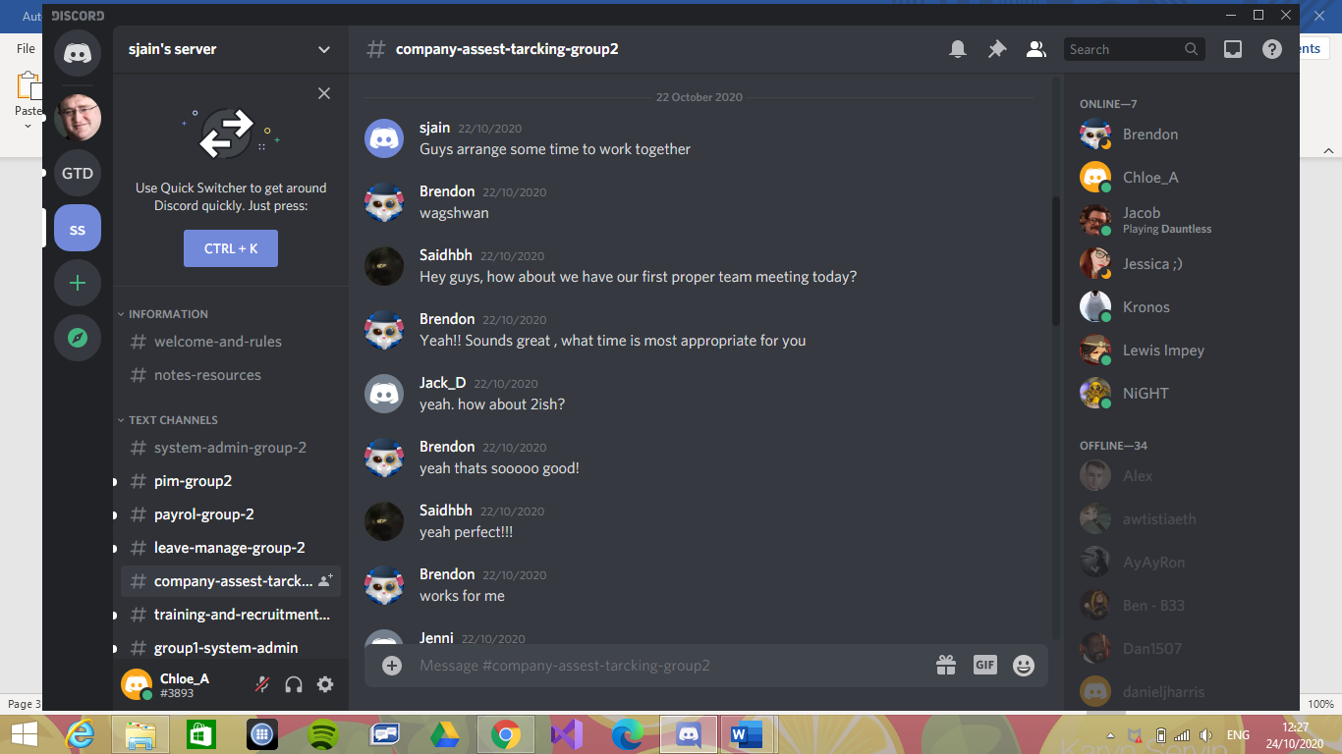

2nd Meeting:

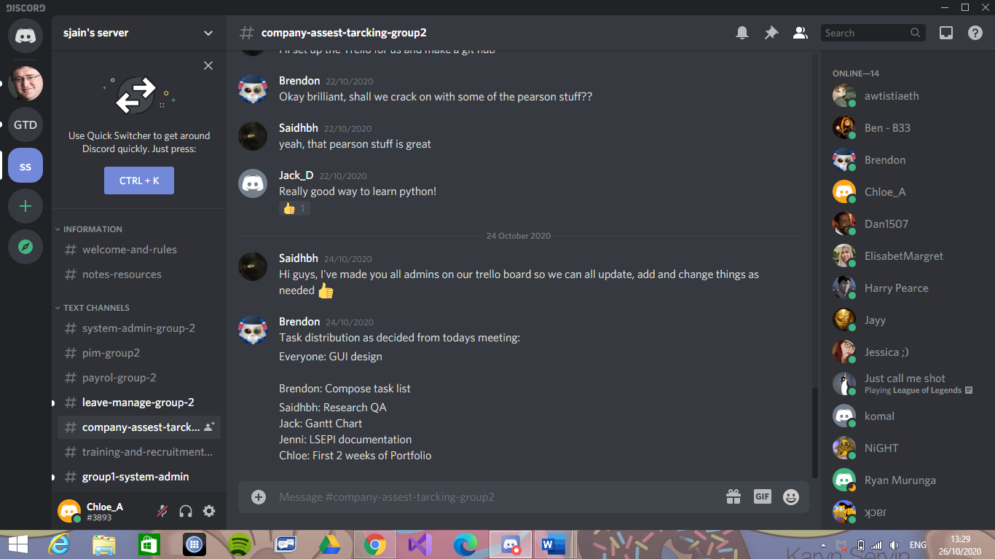

### Week 6

1st Meeting:

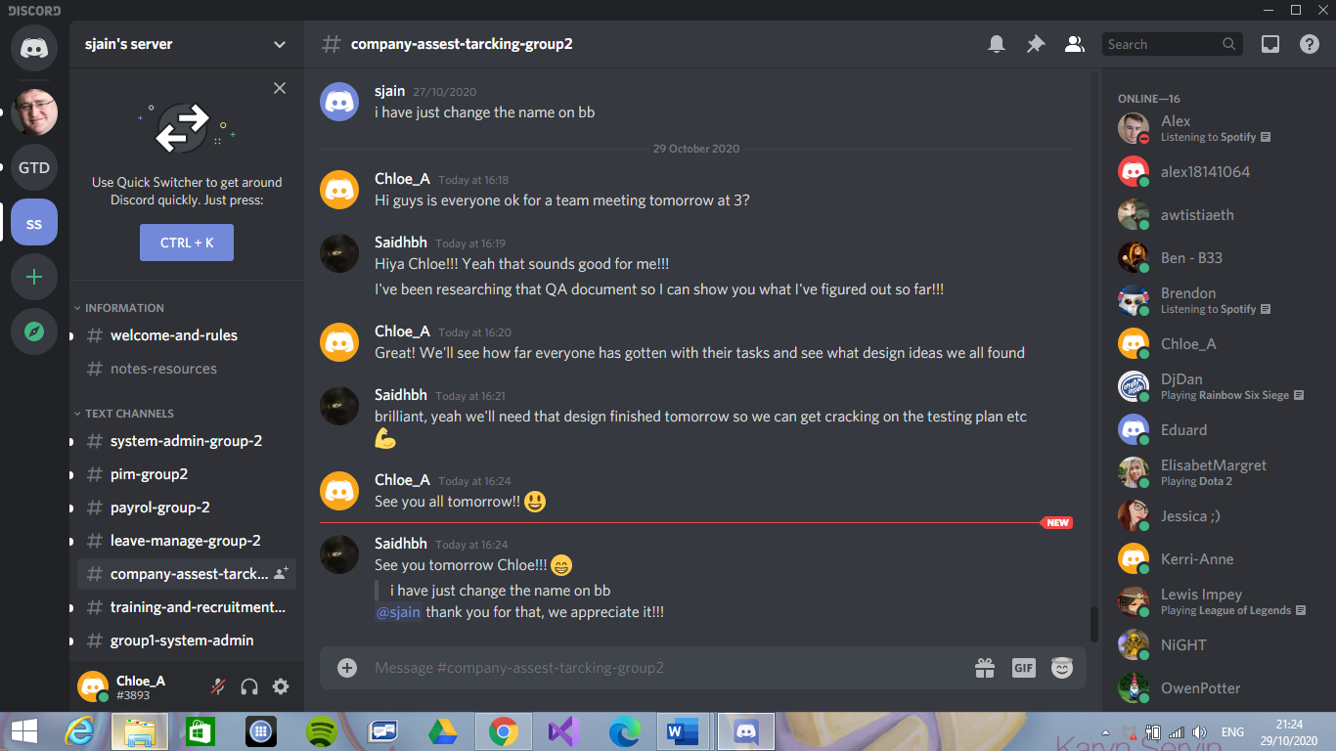

2nd Meeting:

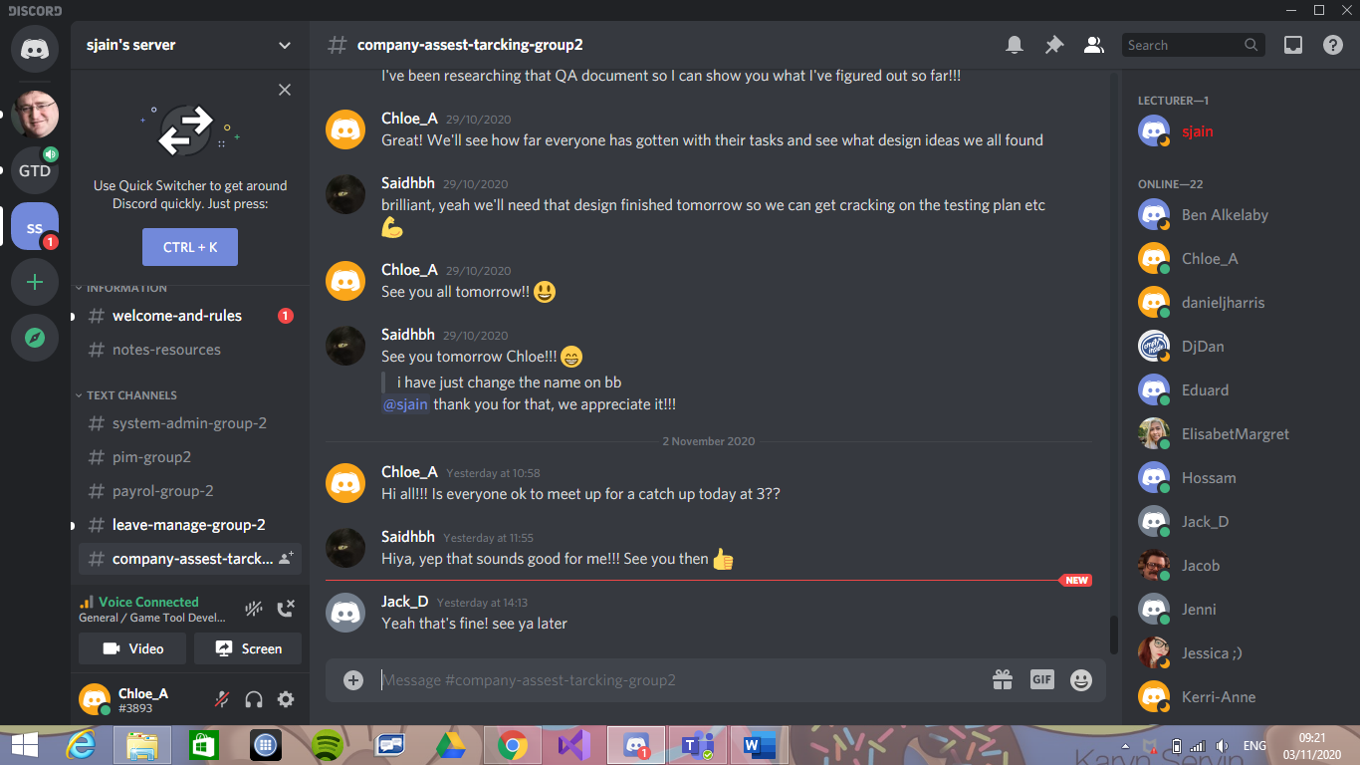

### Week 7

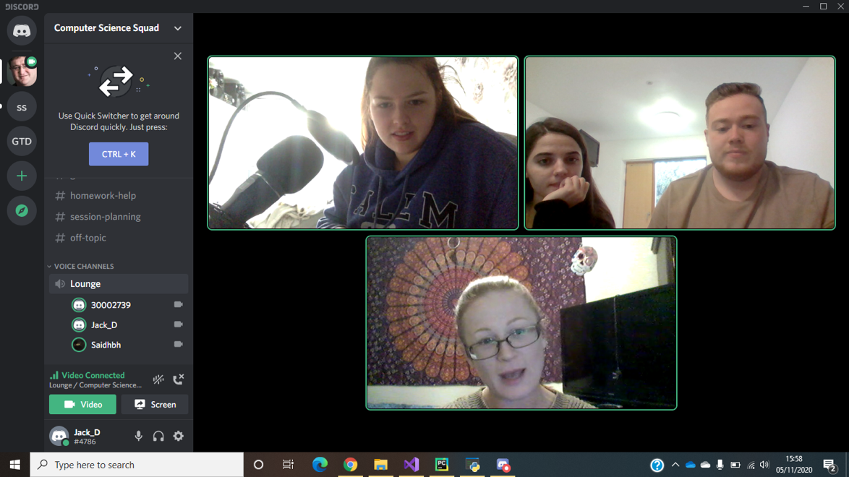

### Week 8

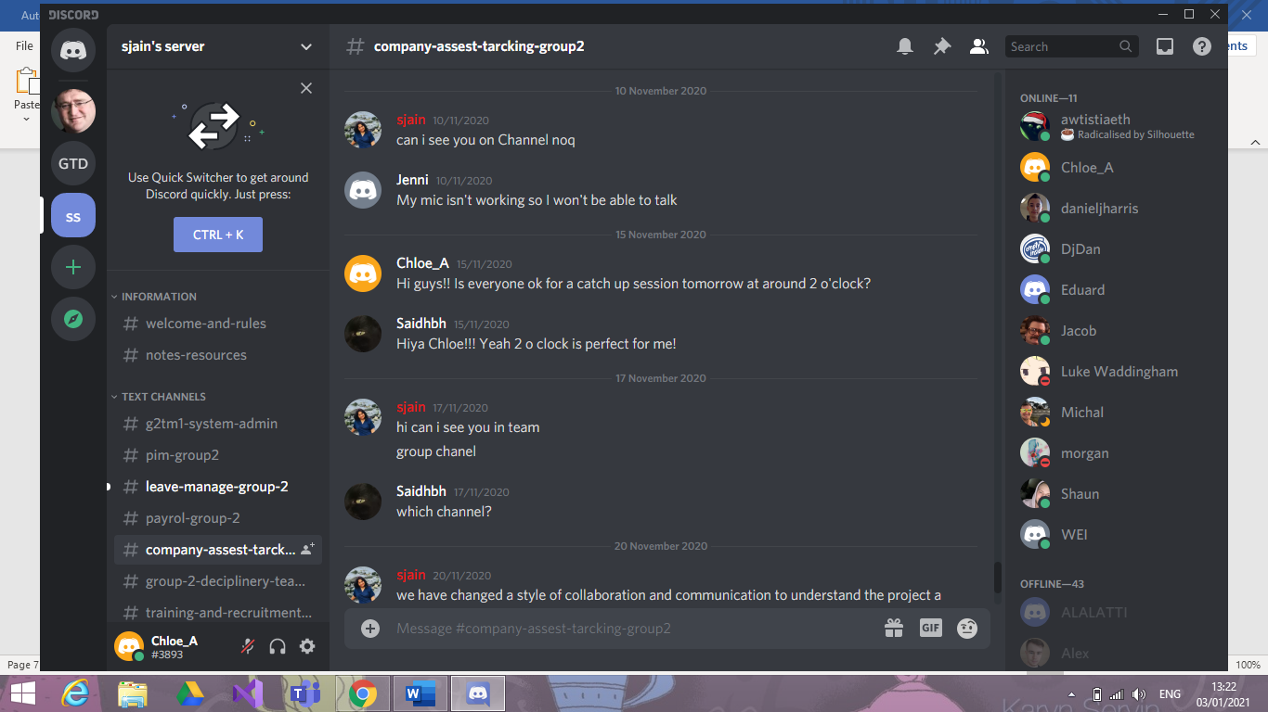

### Week 9

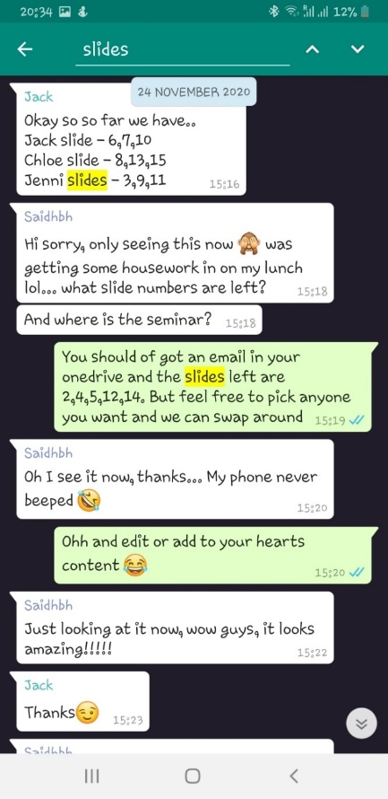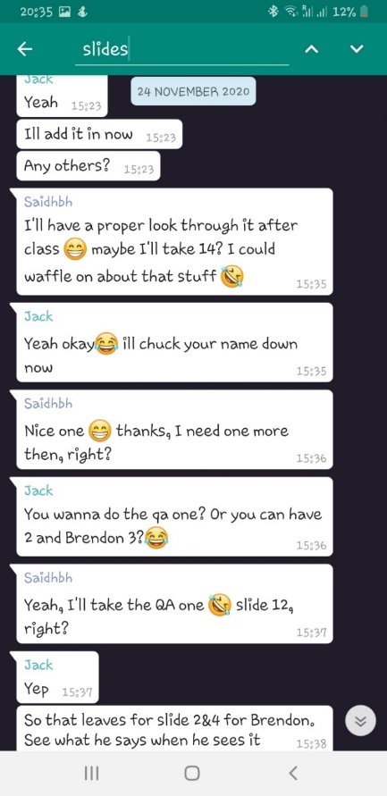

This meeting was through WhatsApp

### Week 11

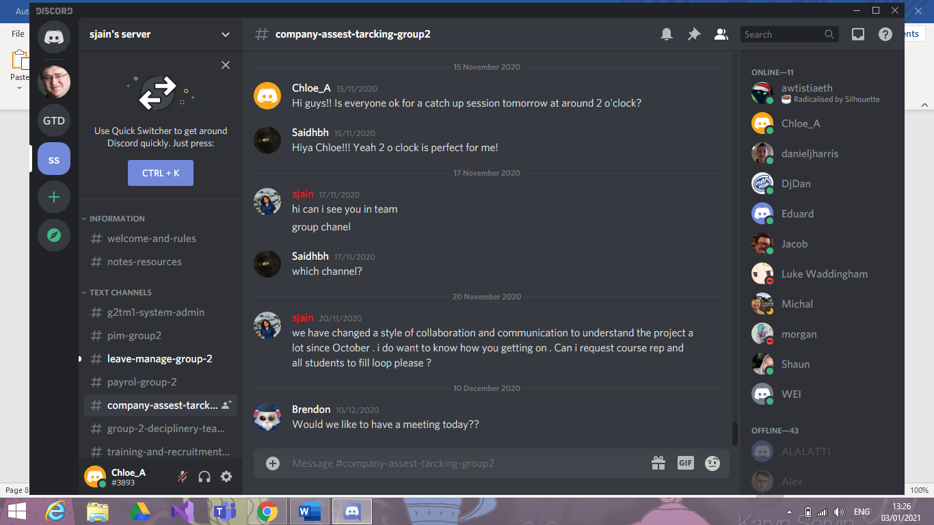

### Week 12

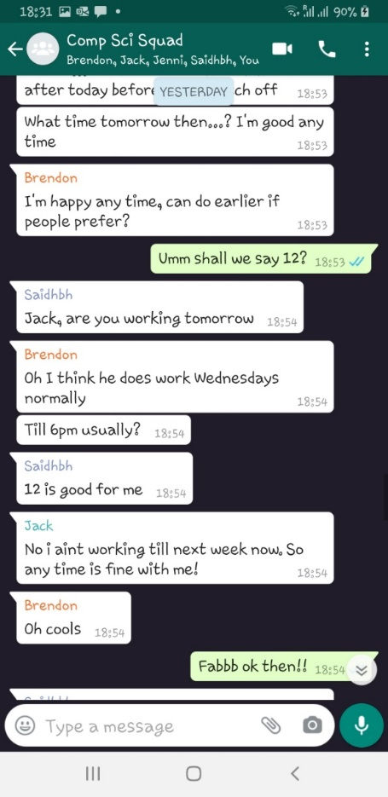

### Week 14

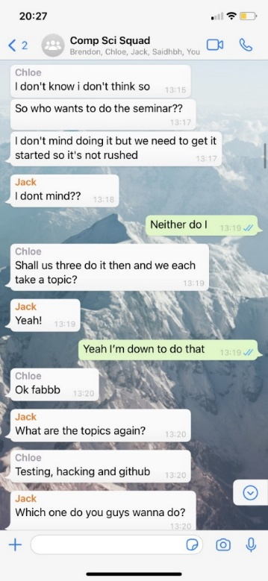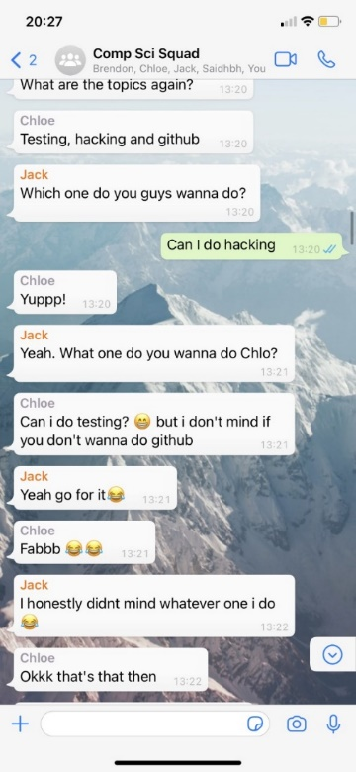

### Week 16

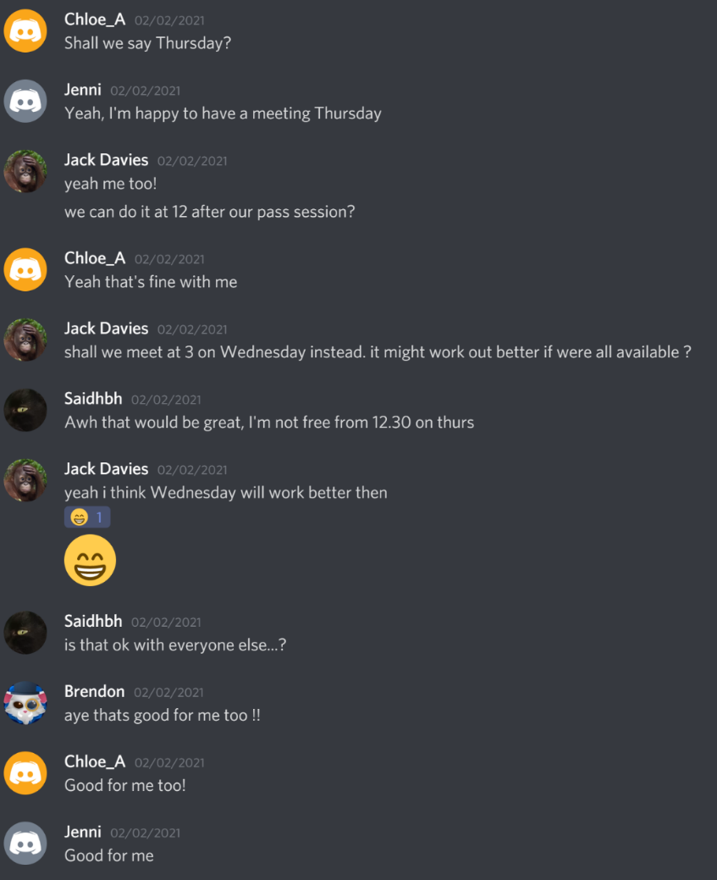

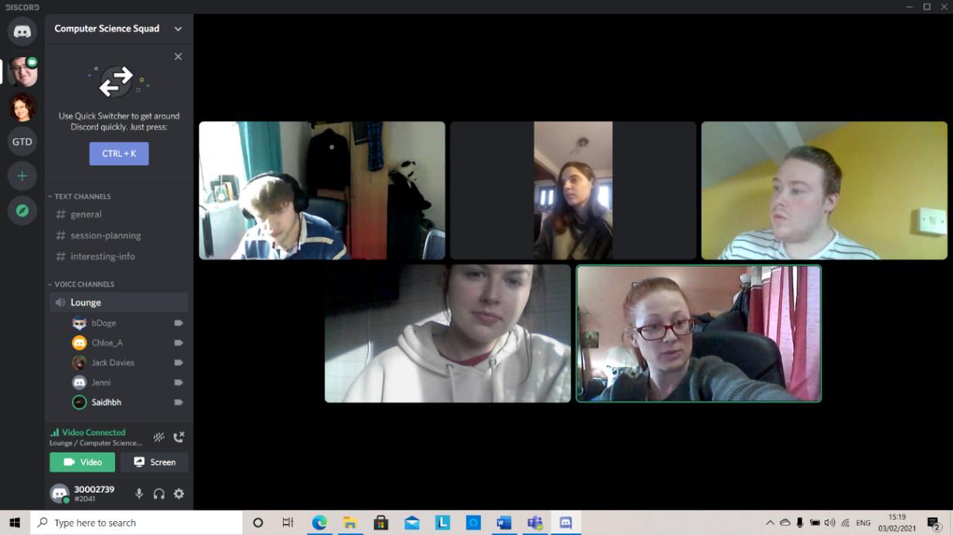

### Week 18

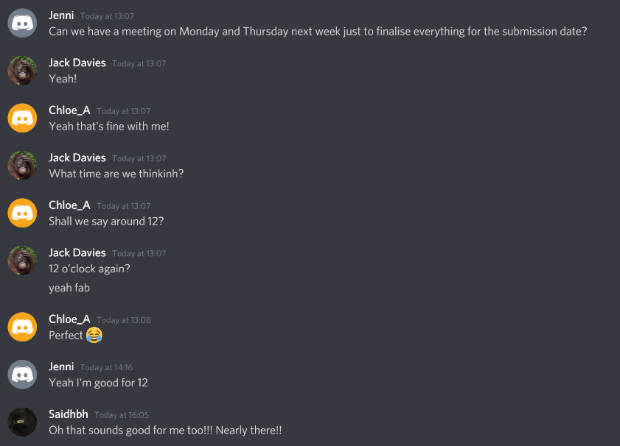

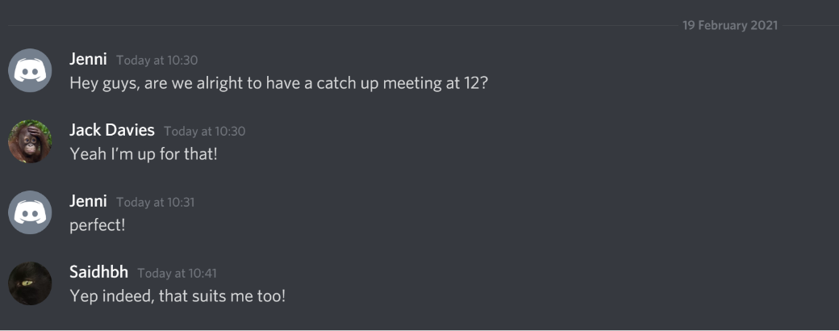

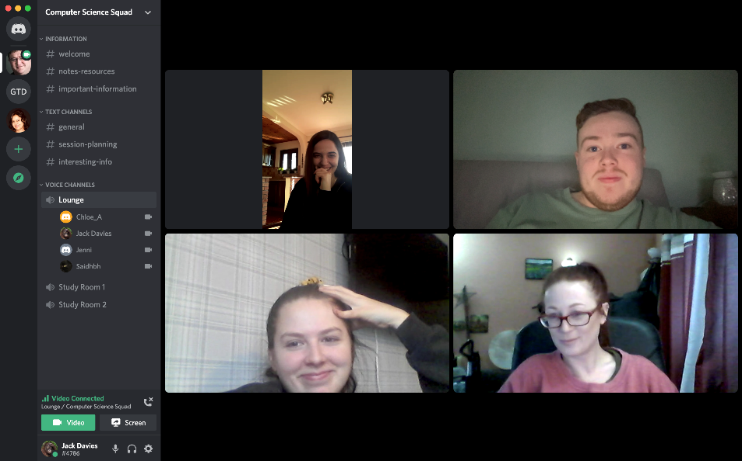

### Week 19

2nd Meeting:

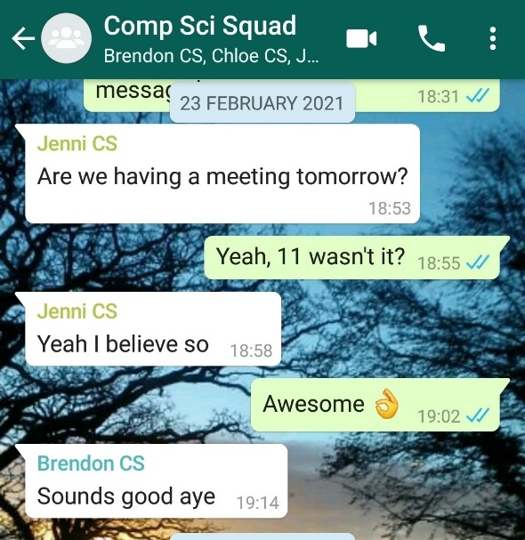

3rd Meeting:

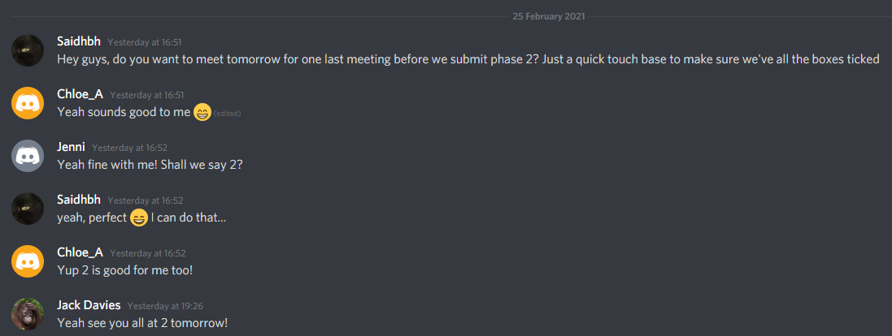

### Week 21

1st Meeting:

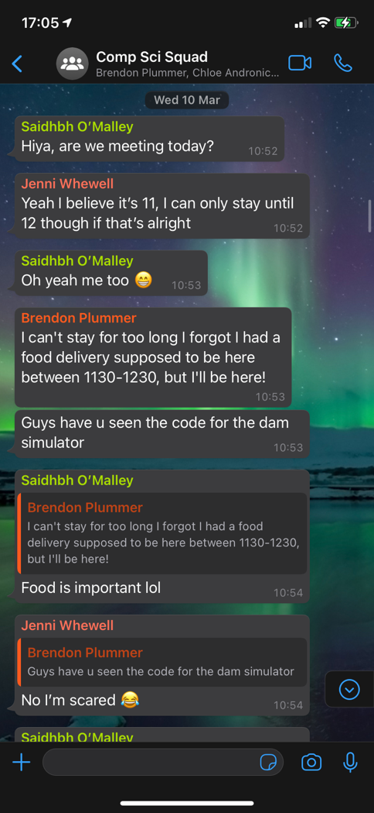

2nd Meeting:

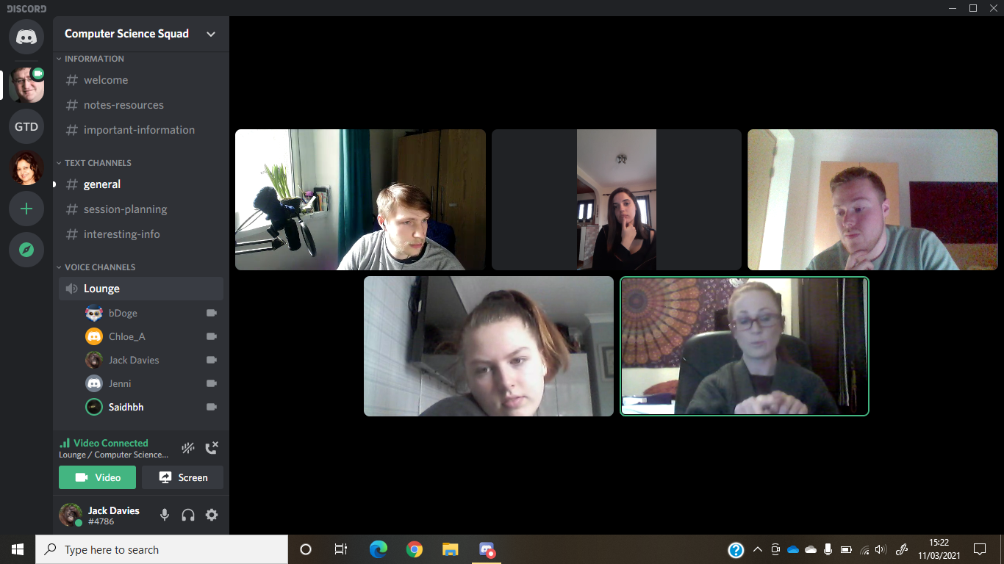

### Week 22

### A screenshot of a computer Description automatically generated with medium confidenceWeek 24

1st Meeting: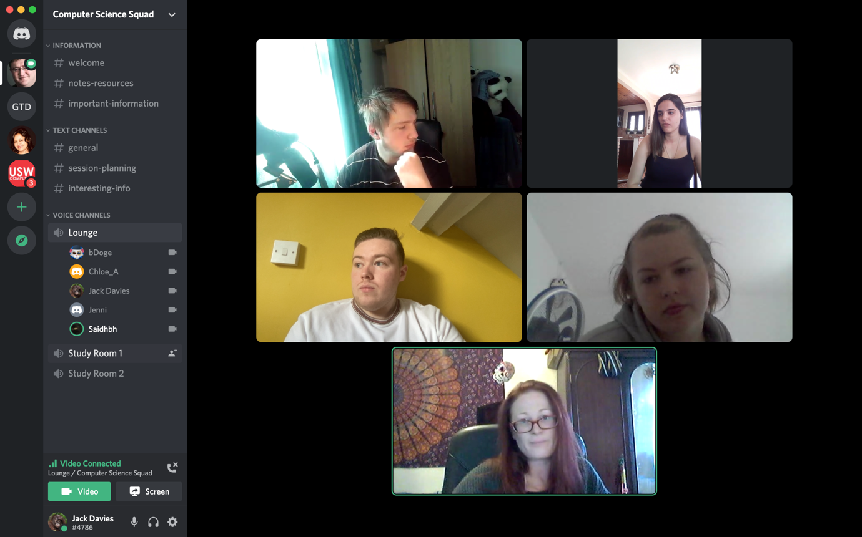

# Additional Evidence

### Week 1

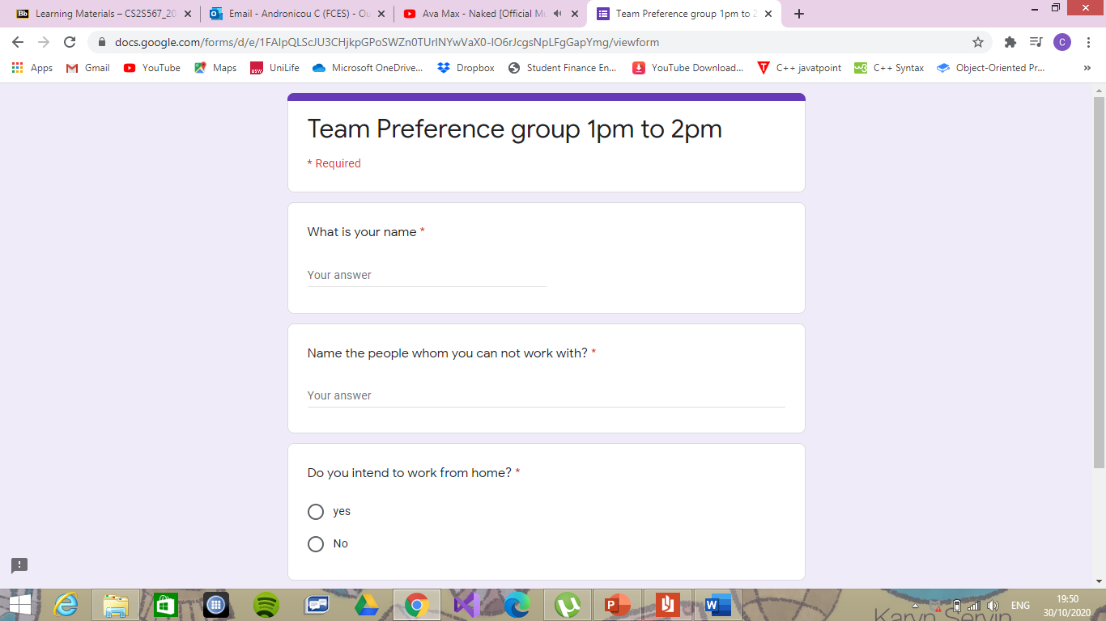

1 Google Forms for Team Allocation

### Week 5

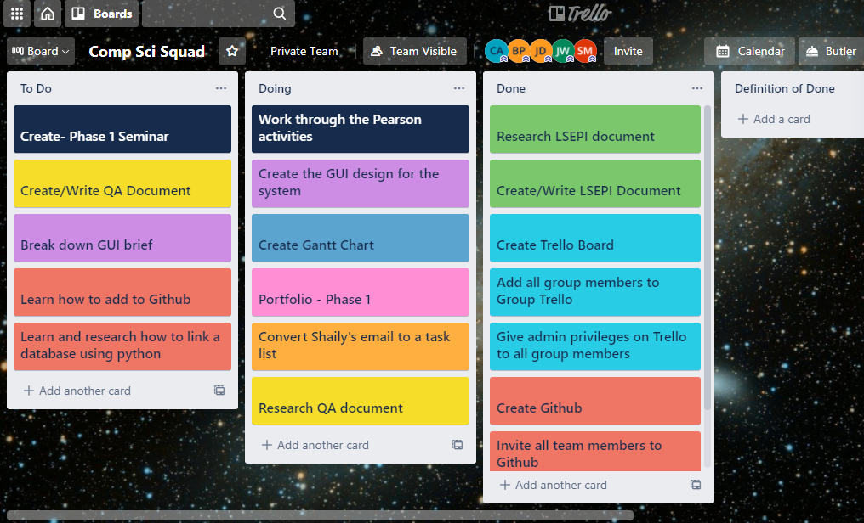

2 Our Trello board that was created

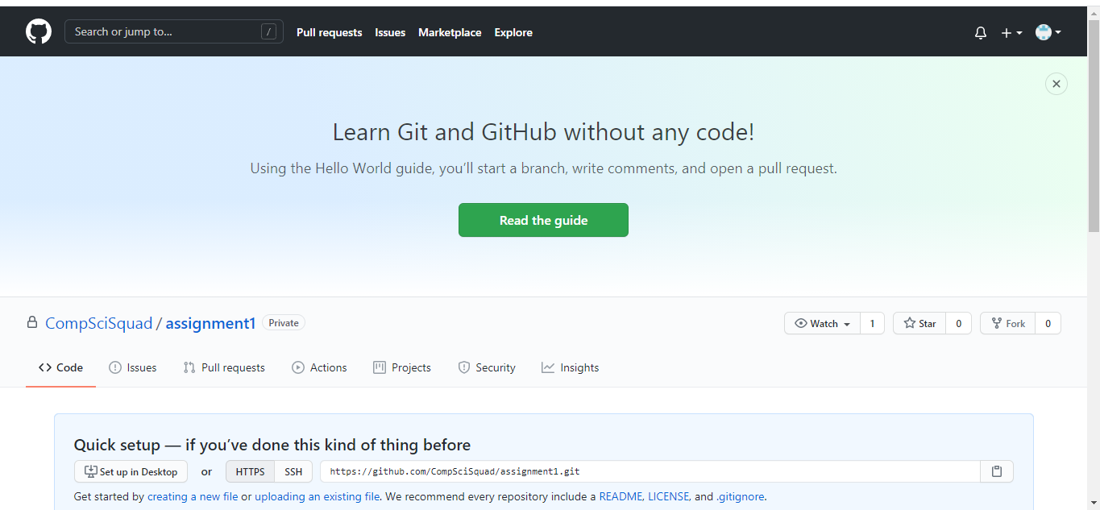

3 Our GitHub that we created

### Week 6

Flowcharts:

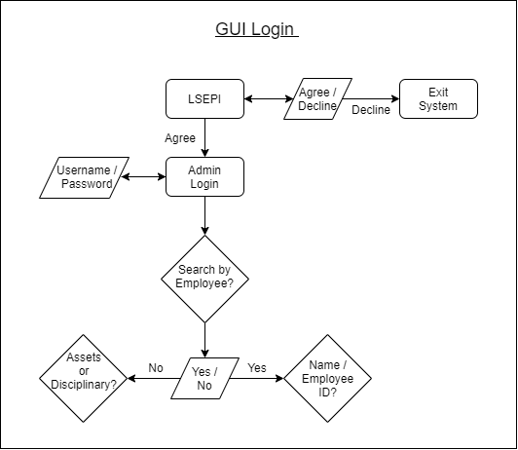

4 Saidhbh’s GUI Flowchart

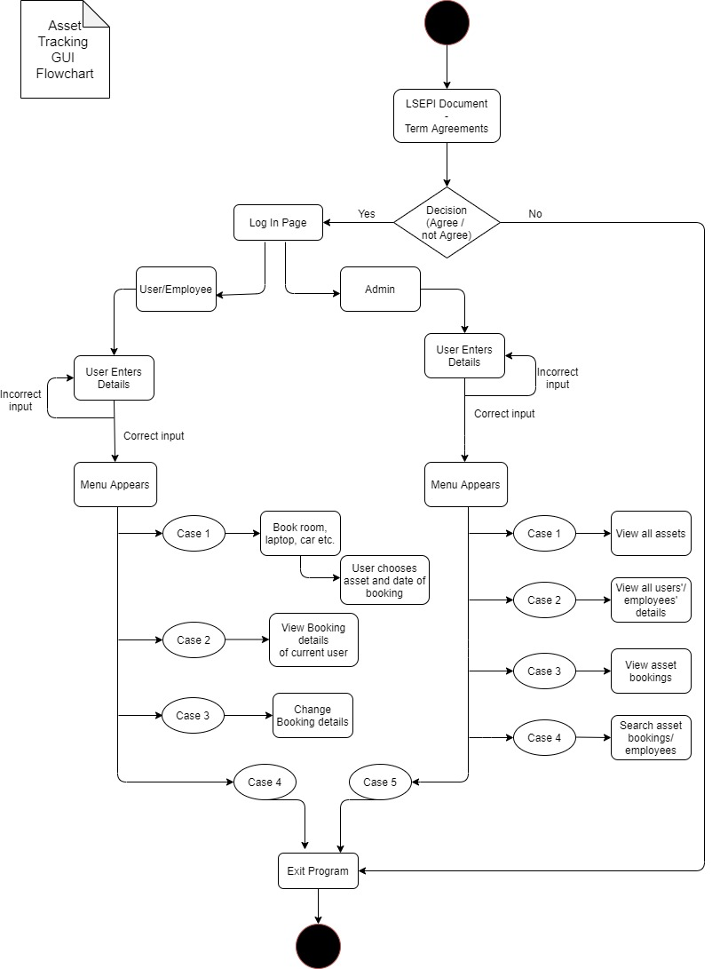

5 Chloe's GUI Flowchart

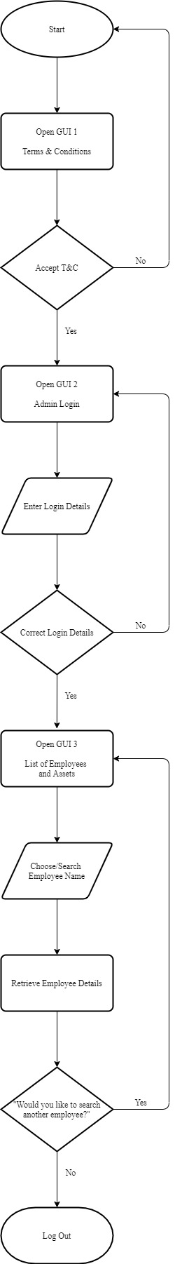

6 Jack's GUI Flowchart

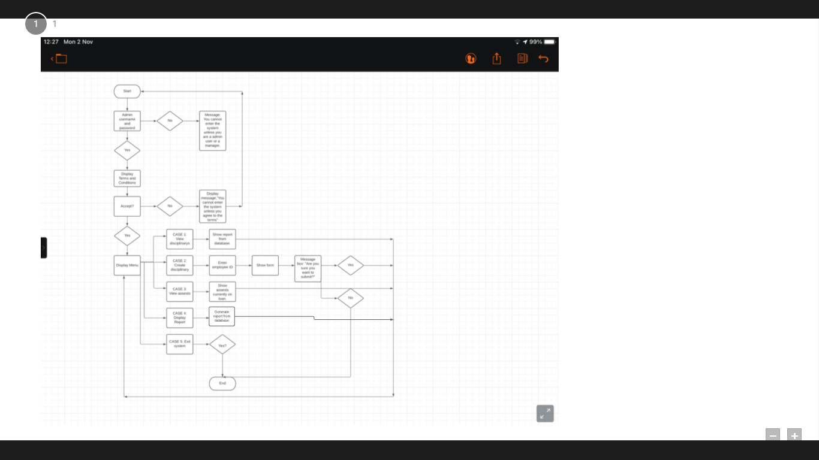

7 Jenni's GUI Flowchart

GUI Design

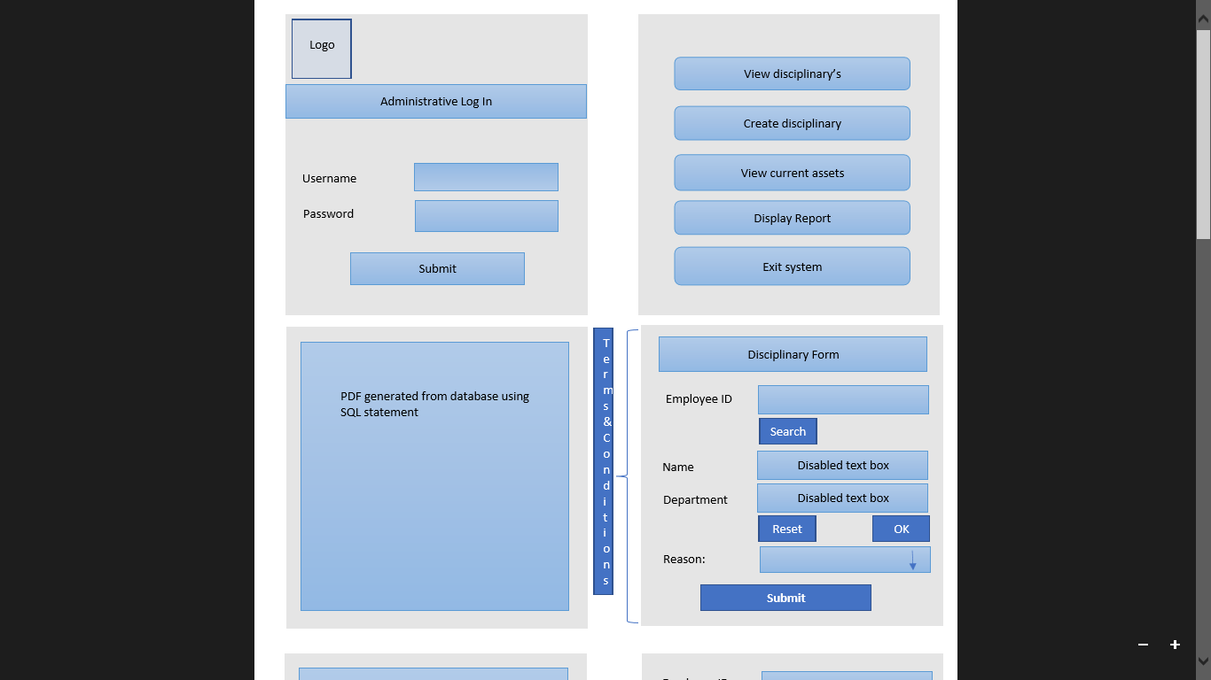

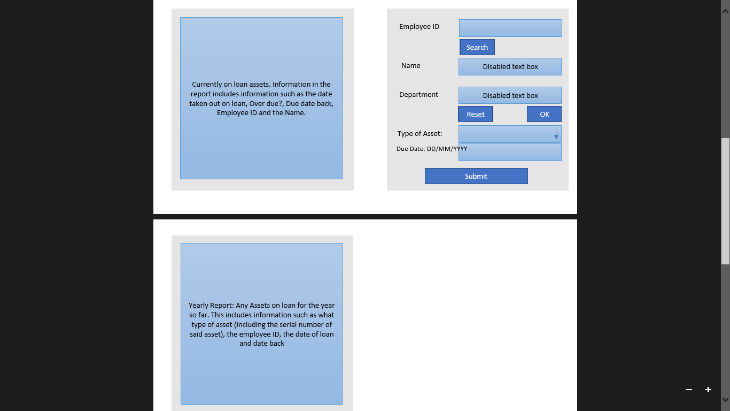

8 Jenni's GUI Design

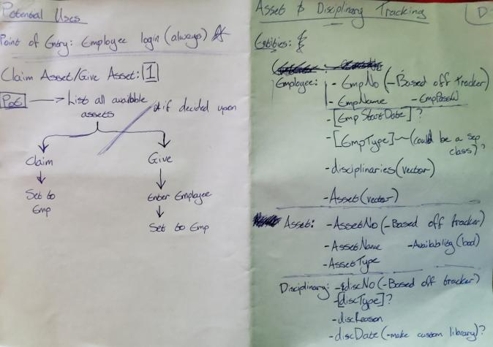

9 Brendon's brief GUI Design Structure

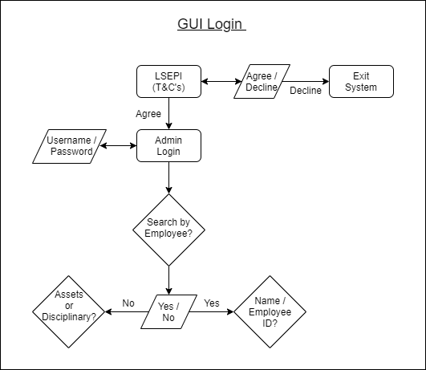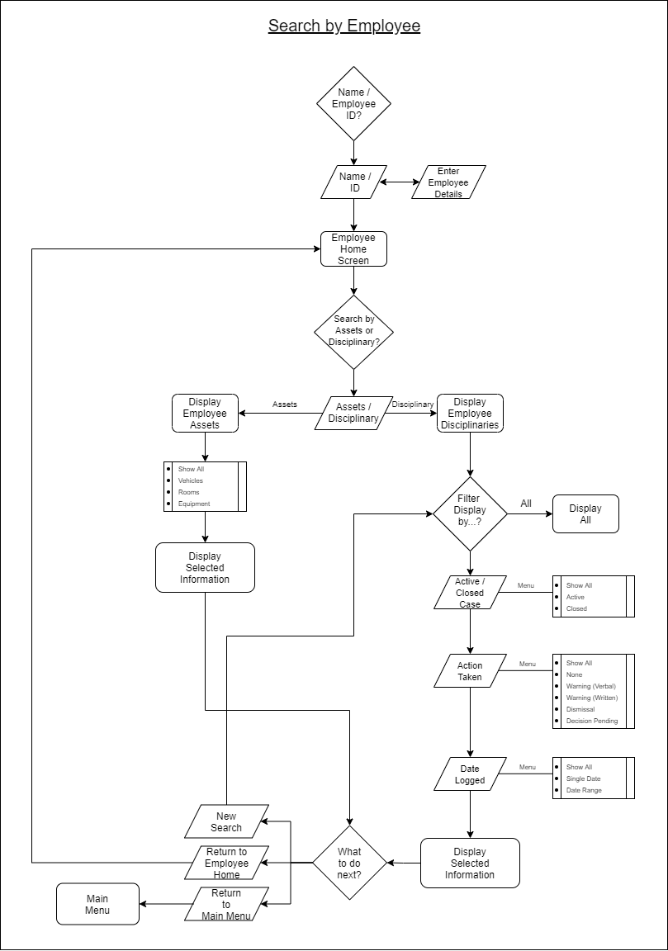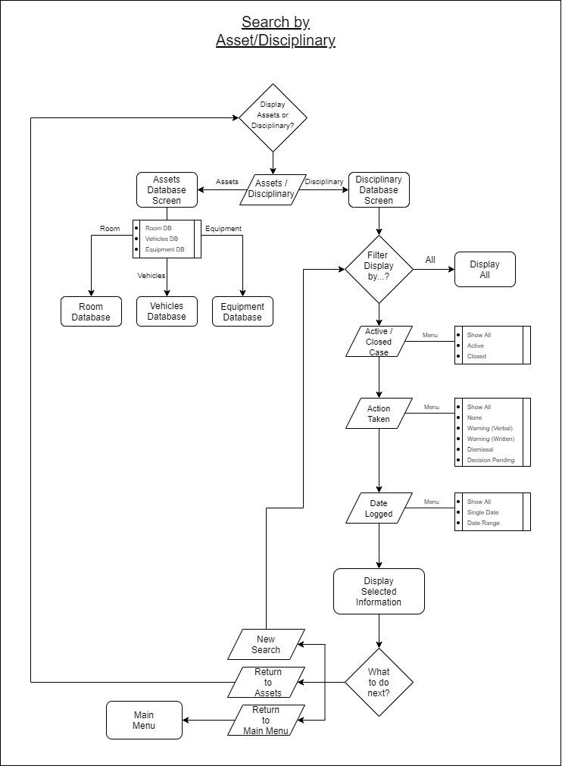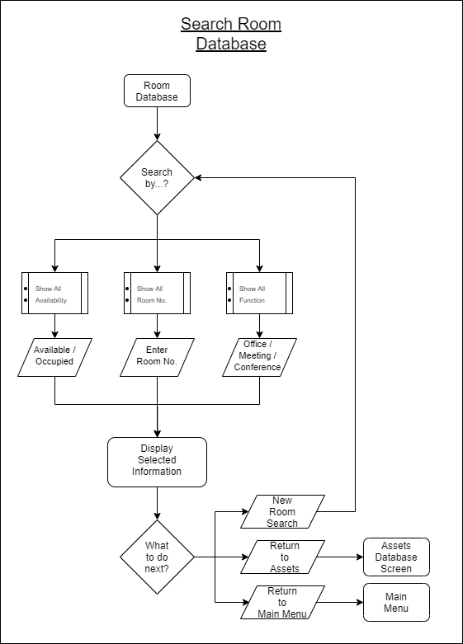

10 Saidhbh's GUI Design (Flowchart style)

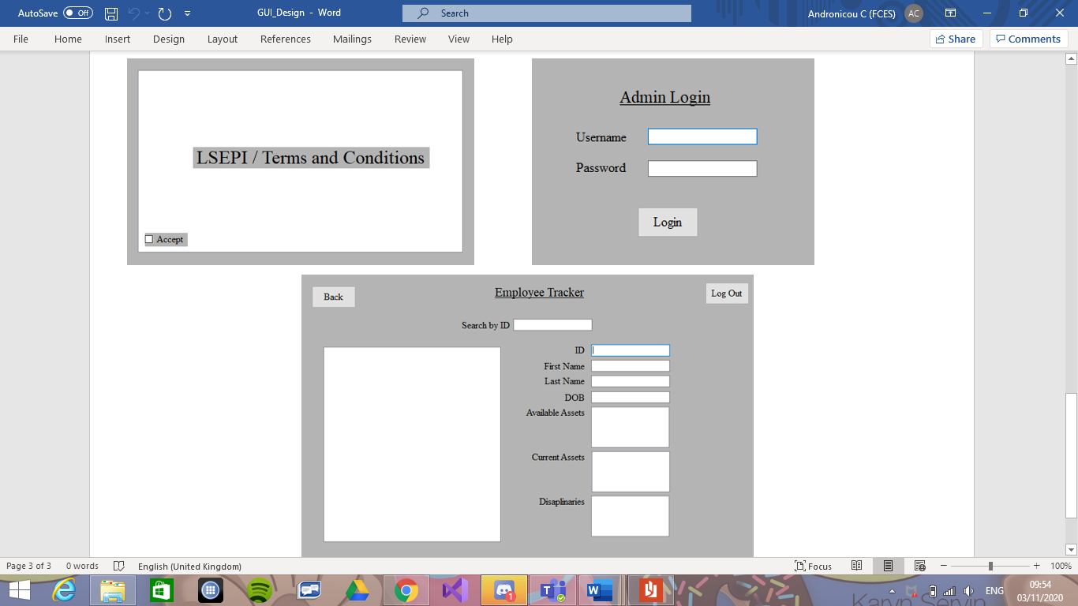

11 Jack's GUI Design

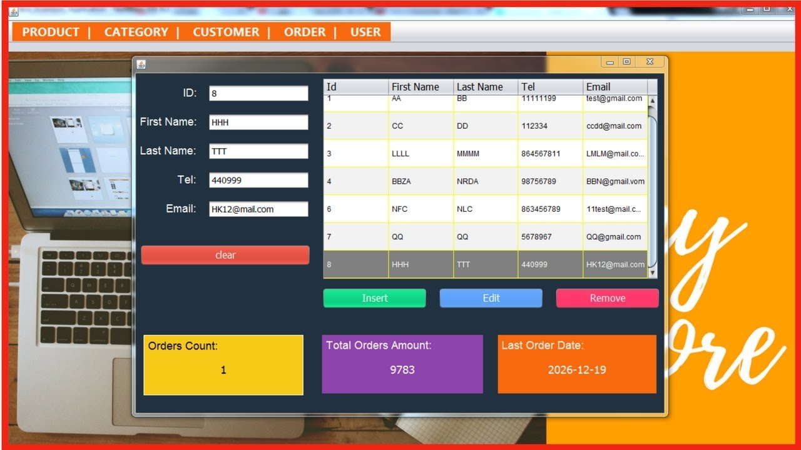

12 One of the images Chloe found to get design ideas for our GUI

LSEPI Documents

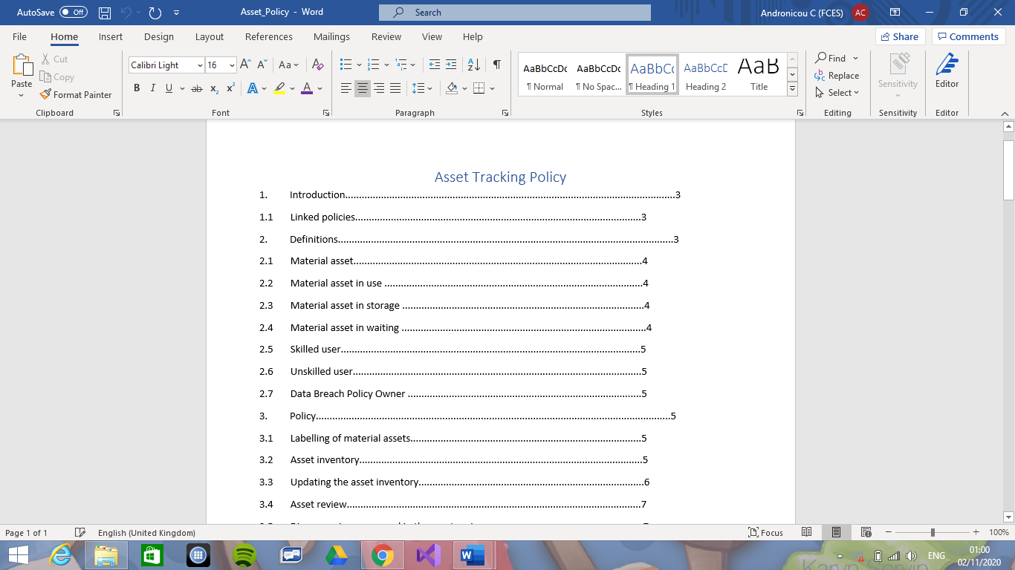

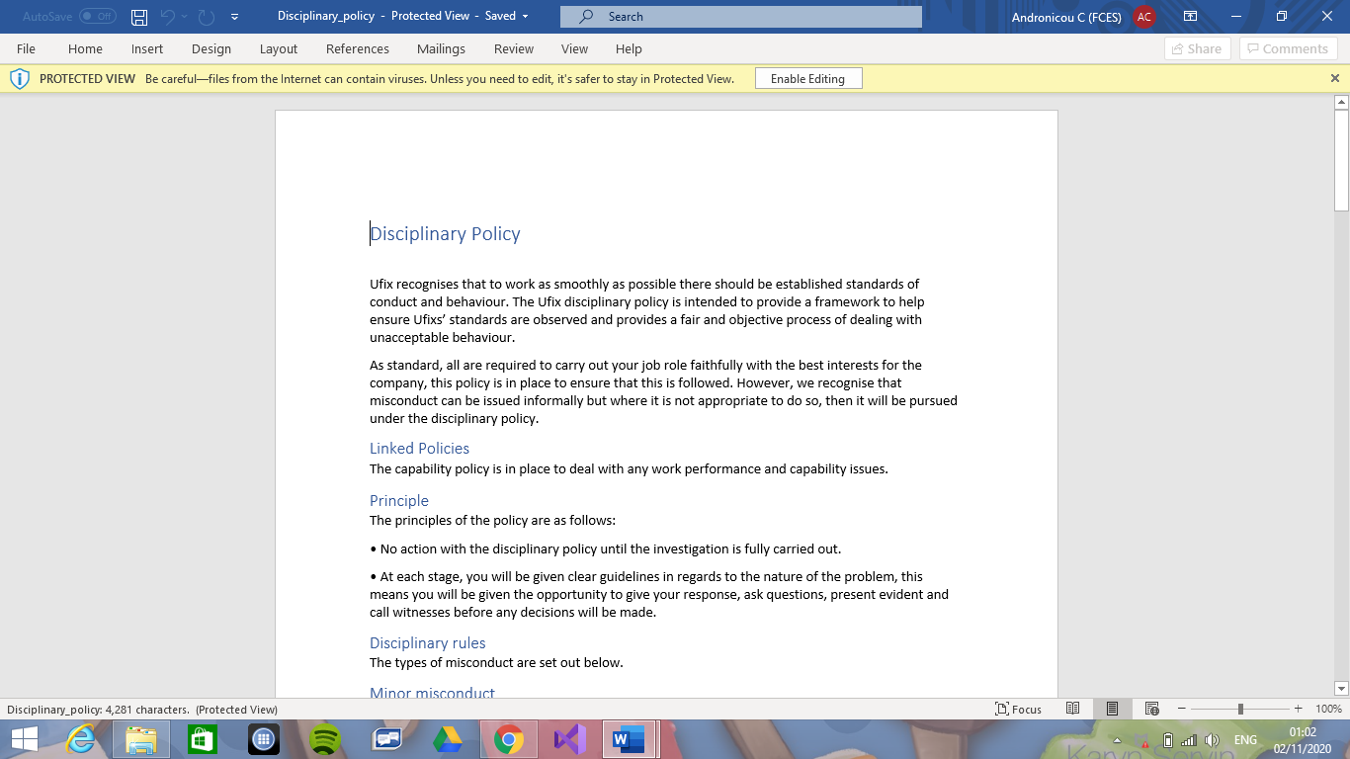

13 Jenni's LSEPI Documents

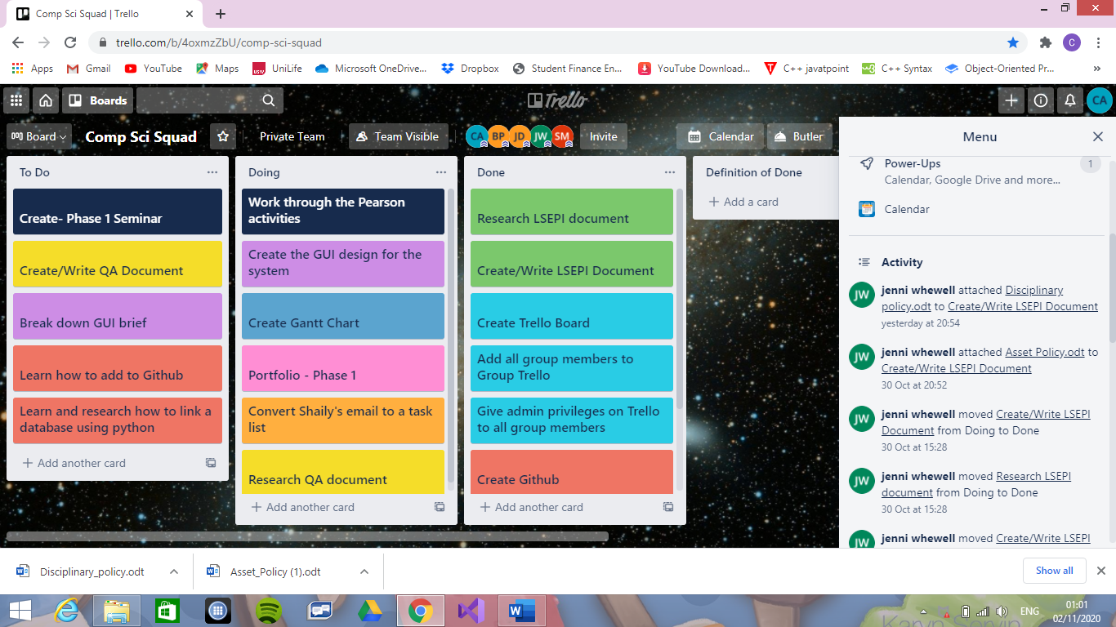

14 Jenni shared the documents with us on Trello

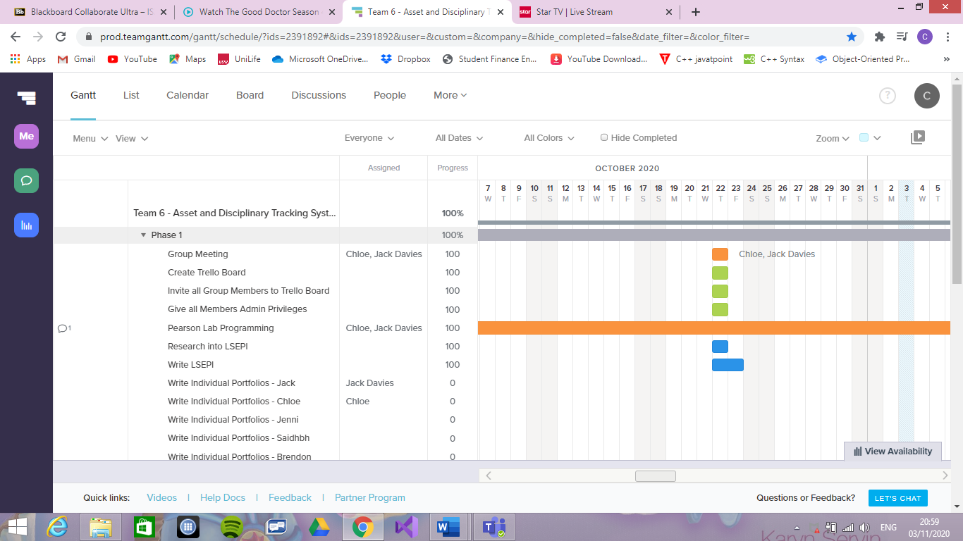

15 Jack's Gantt chart

### Week 9 & 10

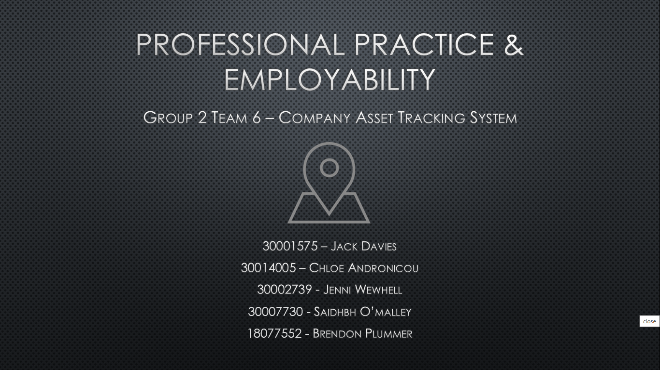

16 Seminar PowerPoint

### Week 12

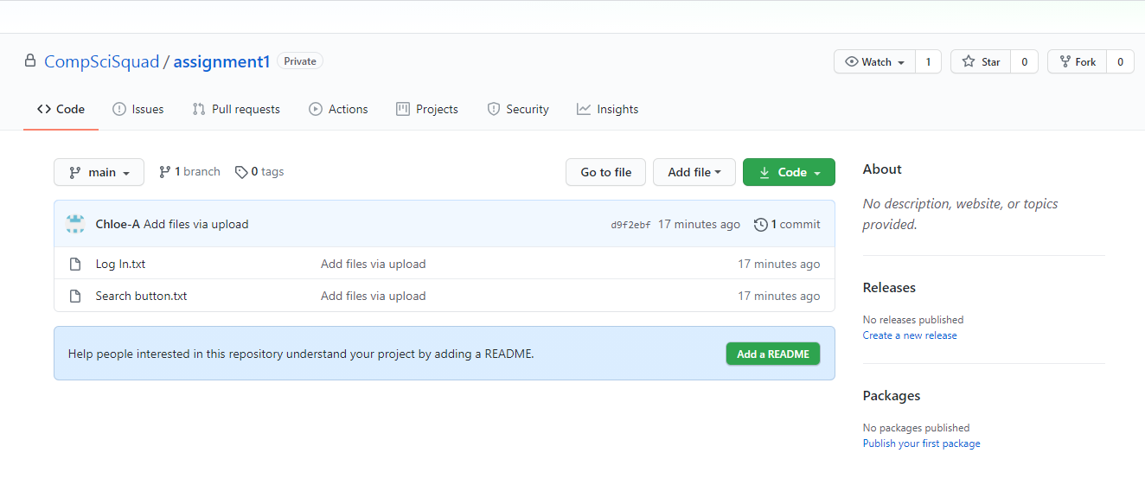

GitHub link: <https://github.com/CompSciSquad/assignment1>

*17 Chloe uploaded some code snippets to GitHub*

### Week 17

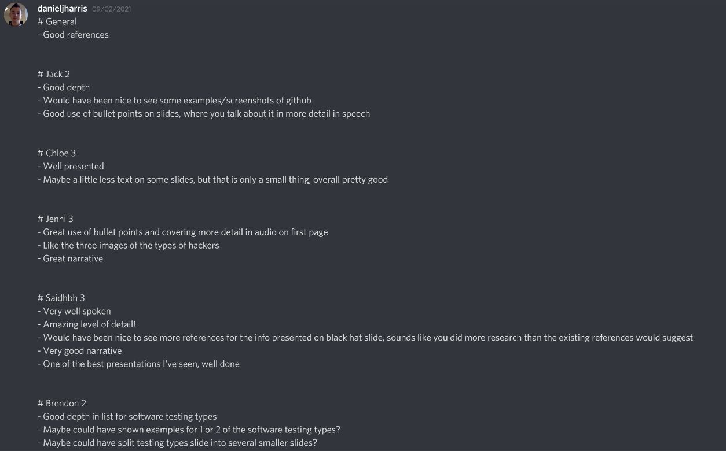

*18 Feedback from Daniel for our Phase 2 Seminar*

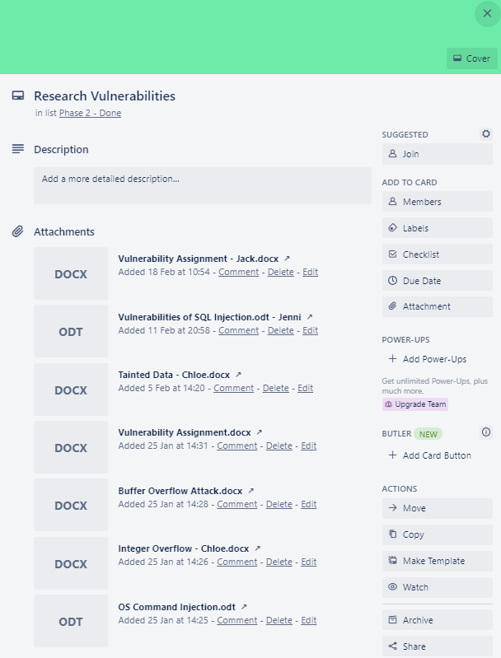

*19 Team members’ individual essays*

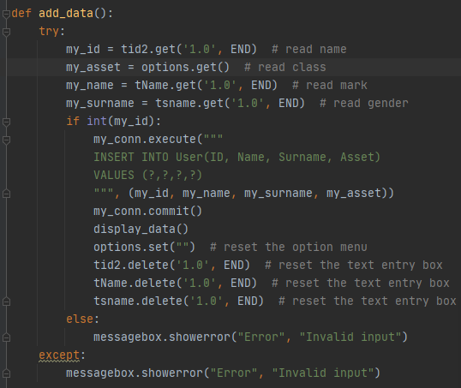

*20 Excerpt of code*

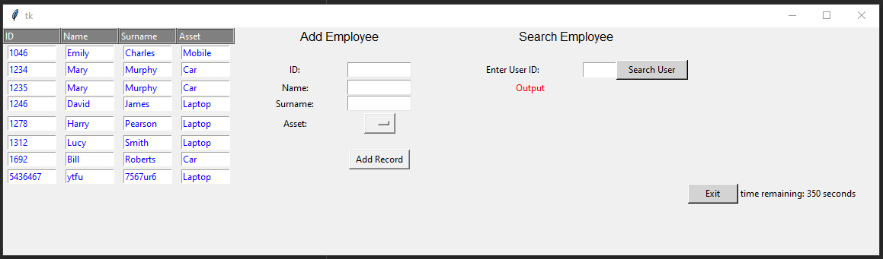

*21 Current ‘Front End’ of our Asset Tracking GUI*

### Week 18

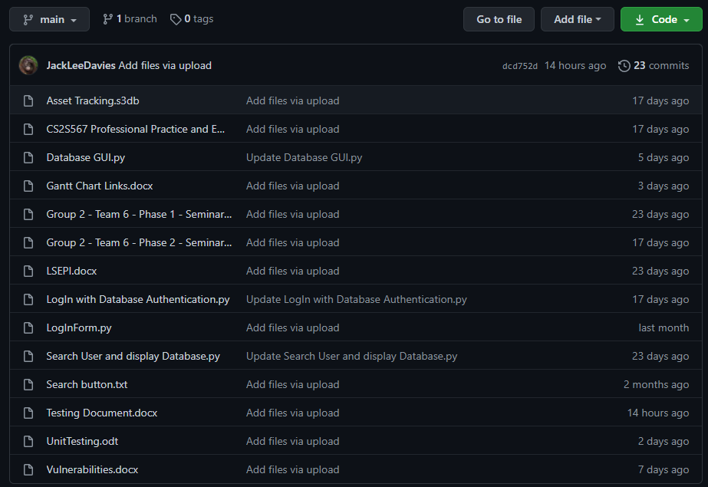

### Week 20

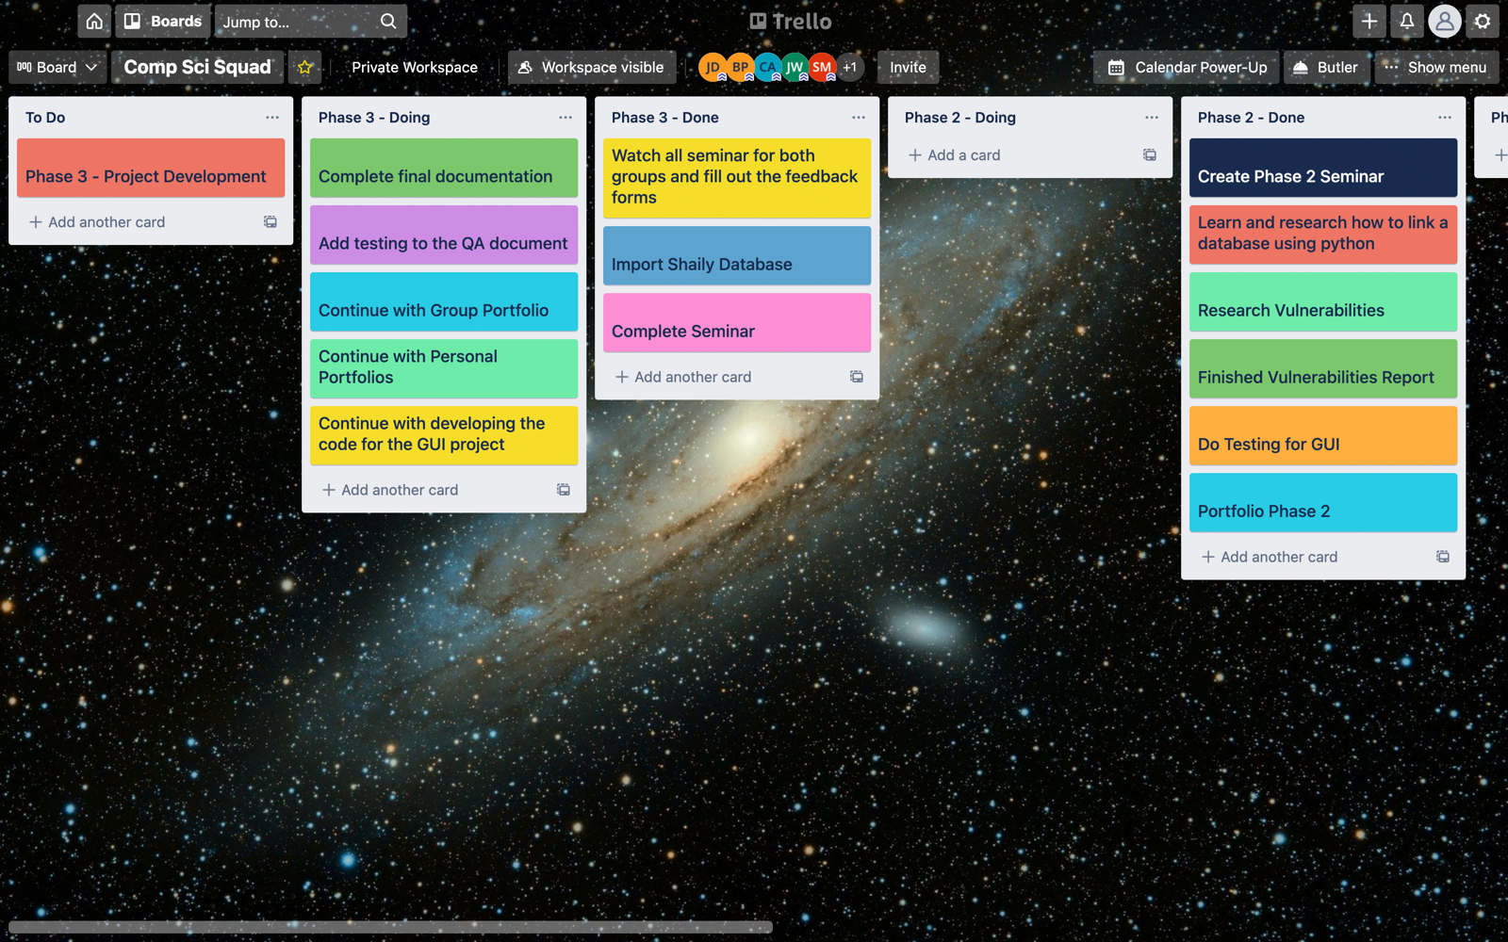

### Week 22

*22 Jenni made a flowchart to show the flow of the GUI Project*

# Documentation Appendix

## LSEPI Document

1. **Introduction**

Ufix recognises that as a business they need to be careful with their data, such data includes client documents, staff data, administrative username, and passwords. All of which must be also kept as a backup in a data centre such as a remote backup server which is highly secured.

All of our assets are kept in a way that a user taking out an asset must comply with the following:

* All equipment be held in a locked rack: Equipment includes assets such as laptops and keys for rooms.
* That the rack be always locked unless a verified engineer is working on site and is physically present at the rack.
* CCTV must continuously monitor the rack and covers the surrounding area of our equipment is located.

This policy does not ignore the fact however, that there may be entities in or out of Ufix that may use said assets for malicious intent to use against Ufix.

* 1. **Linked policies**

This policy has links to, but does not set out here, policies with respect to:

* The security of the data centre environments in which we operate and related access controls. This can be linked to many environments in the company such as the disciplinary aspect.
* Secure disposal of assets.

1. **Definitions**
   1. **Mate rial Asset**

A material asset is identified by Ufix as a means of transportation (cars), the ability to book a room for conferencing, laptops or any means of communication.

* 1. **Material asset in use**

This is a sub class of material asset. All the conditions applying to the definition of a material asset apply to this sub class. A material asset is deemed to be in use when it is electronically active i.e. the tracking of cars using the navigation system installed on the vehicle

* 1. **Material asset in storage**

This is a sub class of material asset. All the conditions applying to the definition of a material asset apply to this sub class.

A material asset is deemed in storage where it has previously been a material asset in use and, therefore is in a state where it is available and deemed in an appropriate state for reuse.

Such an asset will normally be identifiable by criteria such as:

* Being electrically powered or cabled.
* Having evidence of wear and tear associated with prior use.
* Being held in a storage drawer within the environment.
* Being in an unsealed box, anti-static envelope, or similar container.
  1. **Material asset in waiting**

This is a sub class of material asset. All of the conditions applying to the definition of a material asset apply to this sub class.

That is, a material asset in waiting will contain no confidential data, material assets in waiting can be identified as a spare part which will be used to fix an asset in storage.

Such an asset will normally be identifiable by criteria such as:

* Not being electrically powered or cabled.
* Having no evidence of wear and tear associated with prior use.
* Being held in a storage drawer within the environment.
* Being in a supplier sealed box, anti-static envelope, or similar container.

Please note that the material in waiting must be in pristine condition which allows the engineers to install the appropriate software to the devices/vehicles.

* 1. **Skilled user**

Ufix has deemed a skilled to be any individual with the competence to manipulate material assets. A skilled user would, for example, would be capable of exchanging material assets, having use to disciplinary’s/staff data. Ufix has used managers and administration as the example for such skilled users.

* 1. **Unskilled user**

The definition of unskilled users includes, for examples, customer advisors who are capable of identifying individuals who have taken out assets and understanding the system but not having the capability of validating themselves.

* 1. **Data Breach Policy Owner**

Ufix recognises that there must be a person responsible for the management of staff data and the administrative system and therefore have appointed this to the IT security manager

1. **Policy**
   1. **Labelling of material assets**

We will require that all material assets in use and all material assets in storage in any data centre shall be identifiable by a unique, vendor supplied, serial number. This serial number shall be permanently fixed to the material asset by a means that makes attempt to tamper evident.

* 1. **Asset inventory**

An inventory must be created to keep track of said assets, independently of the supplier. A separate inventory must be in use to show the assets on loan at one time. This can be done through the means of a database and must be kept in a permanent form. The database, on demand, should be able to produce a report of the assets in the company and could be exported to PDF for managements use.

As a minimum, for the purposes of this policy, the asset inventory must include, for each material asset in use and each material asset in storage:

* Supplier.
* Serial number.
* Part number or name so that an unskilled user can identify a product for returning and retrieving the products.

Any asset that is broken or at the end of life must be reported and known to the company for replacement/maintenance of the products.

* 1. **Updating the asset inventory**

The separate database data set must be used to represent the following information:

* An asset that has been taken out of use.
* The time and date in which this is done.
* A new asset being introduced into the company.

There may be policies that deal with secure disposal of material assets in storage and related topics. However, this policy is only concerned with tracking the inventory. Updating the information of the

* 1. **Asset review**

A yearly report must be undertaken by the head of IT security management and reviewed by a separate entity from Ufix, this means if there are any discrepancies in the inventory, that it can be investigated by an entity not related to the company, yet they don’t have the ability to make changes to said inventory.

* 1. **Discrepancies uncovered in the asset review**

It is possible that the asset review will reveal discrepancies between the material assets in use or material assets in storage and those recorded on the asset inventory. For example, an asset may have been taken out for a longer period but yet not recorded for said time.

* 1. **Completing the asset review**

Once the asset review has been completed (assuming all discrepancies are deemed valid and the asset inventory duly updated) the following information will be recorded:

* Date of review.
* Name of the reviewing party.
* The employee identifications of the reviewing party.
* Discrepancies, along with the validation of said assets with not being recorded.

The review will then be countersigned by a manager of Ufix who will review all the material and will document it to the system.

POLICY DOCUMENT ENDS

## Quality Assurance Document

### About

This document is to ensure that the quality of our project is of the best possible standard and this is achieved by following certain rules. If the rules are followed, then this high standard is maintained and there is little room for error as a result throughout production.

### Business Rules

*Team Member Qualities*

The qualities of each team member play an important part in the development of our project to the highest standard possible.

All team members have the same skill level concerning coding and are all highly responsible and have good organisation skills. Therefore, we all possess the same qualities and can take our project to its highest possible level of excellence.

Since we all have the same skill level, we will all play an equal role in the development of our project and divide the project between us all. So, we all have a part in writing the code for it and therefore have a part in research which will be done on the code beforehand.

*Project Development Strategy*

A diagram such as a flowchart will first be created depicting the outline of the project. This will assist in getting the right initial design to start off and build the project on. By starting the project with a flowchart, we minimise room for error such as forgetting components of the project.

Our project will be then split into smaller parts and each team member will be assigned a component and will work on it. To assure that each part will be written to its highest standard, the components will be assigned to each team member according to their strengths in the area of code that is needed to write each part. By breaking the project up into segments, it makes it easier to handle and work on and moreover, to prevent the frequent occurrence of mistakes.

Furthermore, each piece of code written by each team member will be added on GitHub when finished, where it will be reviewed by the other members to check for any errors or if there is anything that could be improved.

Once all the project’s segments are completed, they will then be fused together and modified to form the complete version.

The final version of the project will be then tested thoroughly to see if it meets all the requirements and to see if there are any gaps in its functionality or if anything needs improving.

# 

### Database

We were given the option of choosing any Standard Query Language (SQL), however were encouraged to try SQLite as a starting point of the project. Although at this point the team has had previous experience with MySQL through other modules on our course, after doing some research into SQLite and its functionality we decided to stick with it. This is mainly for its ease of use, small amount of effort to set up, and its relative ease to pick up syntactically due to its similarity to other languages.

SQLite, created by Dr. Richard Hipp, had created it with application use in mind. Unlike other query languages used more typically for big enterprise data depots, requiring extensive setup processes to ensure proper data redundancy, SQLite runs within the same application address and requires no configuration to setup. Using SQLite keeps the program fully encapsulated without the need of communication with an external process, as seen when using MySQL for example. With all this in mind however, we decided we would continue with the pearson learning and decide after having a deeper understanding of python and its workings.

After having more experience with Python, it was a continued feeling of preference towards SQLite and its simplicity. Additionally, after more research into the language it was discovered its commonly used amongst conglomerates for most embedded systems, including companies such as Apple, Google and most android based companies. We did also learn however of SQLites main disadvantage, it is very poor for allowing multiple users to access the data at once, especially when trying to consider certain access requirements for each of user. With this in mind, SQLite still is the more suited database library for us to use, having only one user accessing the data at any given time with no change in access requirements, we see no reason for overcomplicating the program with something more extensive.

### Application Design and Installation

### *Application Design*

Our project application launches with a log in page where the user is prompted to log in using their username and password.



If the log in was successful, then the user will be directed to a new page.

The page that they are directed to has the following screen components:

* A search feature to search for an employee or an asset
* An add / create feature that allows the user to add a new asset or employee
* A feature that allows the user to view all available employee details and/ or assets
* A delete feature that allows the user to delete an employee or asset if need be
* A save feature to save any changes to the database
* A booking feature that enables the user to book an asset
* An exit button for the user to terminate the program

All above features are based on the application mockup and are not confirmed features which might therefore change until the completion of the program.

### Installation

Once the application is installed, they will be given instructions on how to connect it to their database for it to work. No further instructions will be required as the application is designed in such a way to be simple to use and for its features to be self-explanatory.

The user will however need to agree to certain terms before proceeding after logging in for the first time which are all stated in the LSEPI document. These terms include but are not limited to data protection and the integrity of the user.

## Testing

### Manual Testing

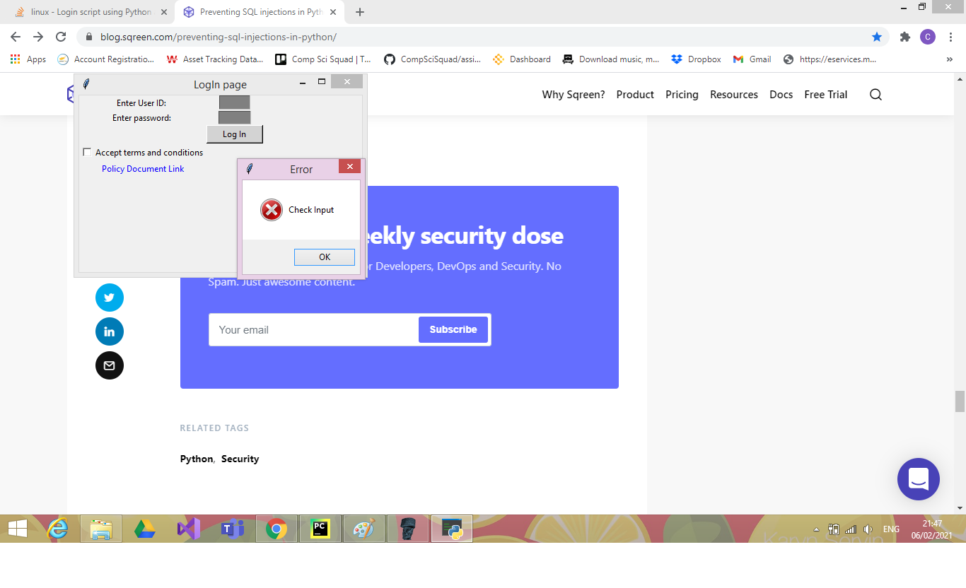Test Plan 1

|  |  |  |  |
| --- | --- | --- | --- |
| Date: | 25/02/21 | Tested By: | Jack Davies |
| System: | Login Page | Environment: | Python |
| Objective: | Check if the system will login without entering any details or accepting the terms and conditions box. | Test ID: | 1 |
| Version: | 1 | Test Type: | Absent |
| Status: | In Process |  |  |
|  | | | |
| Type of Tests | Before | After | Result |
| * Invalid * Boundary * Valid * Wrong * Absent | The type of test that will occur will be an absent test. This test will include no input to see if the appropriate error will occur. | The type of test in the above screenshot is an absent test. As you can see, no data has been entered into the textboxes and the terms and conditions box has not been accepted. | As there was no data being entered and tick boxes have not been ticked, an error message has occurred to tell the user to check their input. This test was successful because we do not want our program to allow the user to login without the correct login details and without accepting the terms and conditions. We also do not want our program to crash either if an error occurs. |

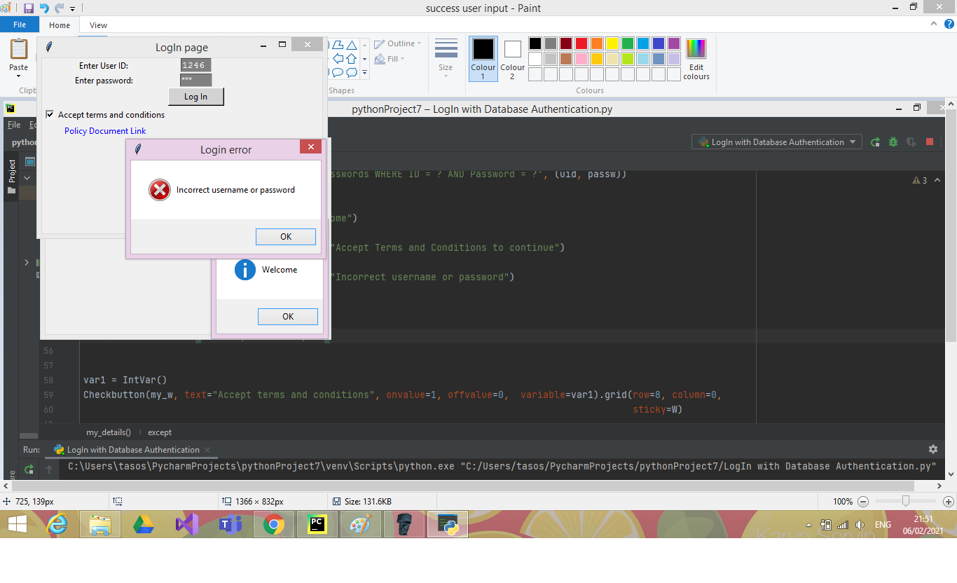Test Plan 2

|  |  |  |  |
| --- | --- | --- | --- |
| Date: | 25/02/21 | Tested By: | Jack Davies |
| System: | Login Page | Environment: | Python |
| Objective: | Try to login without entering the correct login details | Test ID: | 2 |
| Version: | 1 | Test Type: | Invalid |
| Status: | In Process |  |  |
|  | | | |
| Type of Tests | Before | After | Result |
| * Invalid * Boundary * Valid * Wrong * Absent | The type of test that will occur will be an invalid test. This test will include inputting incorrect details to see if the system will login in or if the appropriate error will occur. | The type of test in the above screenshot is an invalid test. As you can see, the wrong details have been entered into the textboxes. However, the terms and conditions have been accepted which means the only error that should occur would be about incorrect login details. | An incorrect username and password have been entered, which created an error. This test was successful because the user should not be allowed to login with incorrect details. The correct error message appeared too, and the program did not crash. |

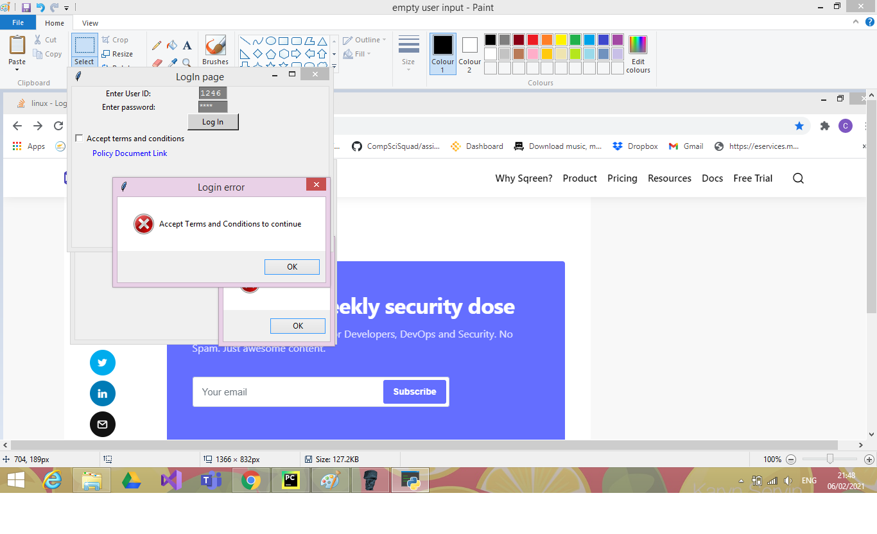Test Plan 3

|  |  |  |  |
| --- | --- | --- | --- |
| Date: | 25/02/21 | Tested By: | Jack Davies |
| System: | Login Page | Environment: | Python |
| Objective: | Try to login without accepting the terms and conditions. | Test ID: | 3 |
| Version: | 1 | Test Type: | Absent |
| Status: | In Process |  |  |
|  | | | |
| Type of Tests | Before | After | Result |
| * Invalid * Boundary * Valid * Wrong * Absent | The type of test that will occur will be an absent test. This test will try to login without accepting the terms and conditions. | The type of test in the above screenshot is an absent test. As you can see, the terms and conditions box has not been ticked which means the user should be able to login without accepting it. | This test was successful because the user did not accept the conditions and an error message appeared informing the user to accept the conditions if they wish to continue. |

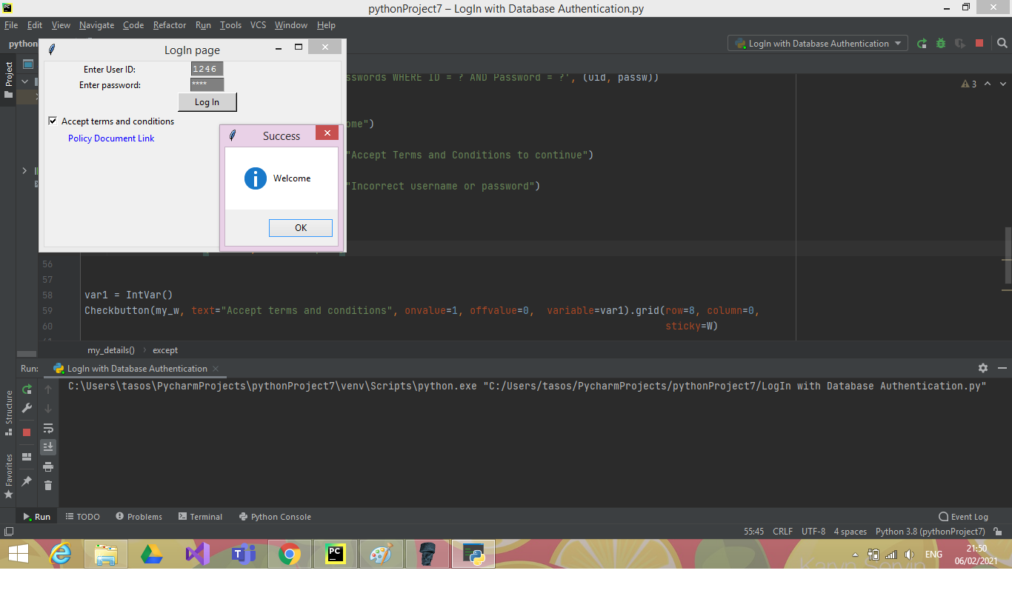Test Plan 4

|  |  |  |  |
| --- | --- | --- | --- |
| Date: | 25/02/21 | Tested By: | Jack Davies |
| System: | Login Page | Environment: | Python |
| Objective: | Login by using correct usernames and passwords and by clicking the accept button for the terms and conditions. | Test ID: | 4 |
| Version: | 1 | Test Type: | Valid |
| Status: | In Process |  |  |
|  | | | |
| Type of Tests | Before | After | Result |
| * Invalid * Boundary * Valid * Wrong * Absent | The type of test that will occur will be a valid test. This test will try to login by using correct usernames and passwords and by clicking the accept button for the terms and conditions. | The type of test in the above screenshot is a valid test. As you can see, the terms and conditions box has been accepted and the data has been inputted for the username and password. | This test was successful because the user entered correct login details and they also accepted the conditions. No error message appeared, on a message to say welcome to the user. |

Test Plan 5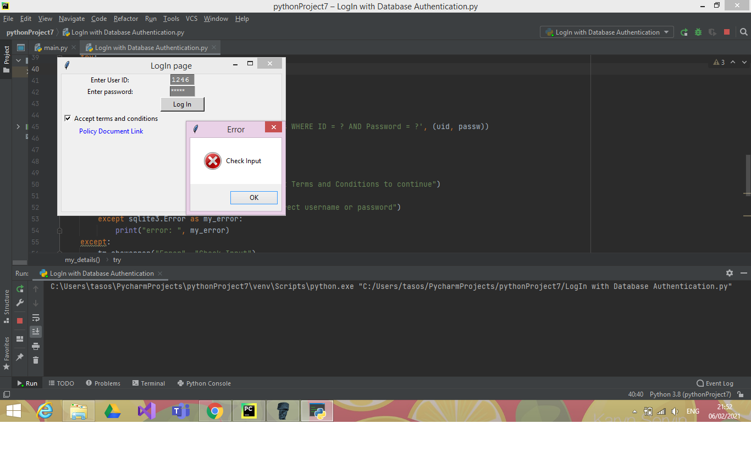

|  |  |  |  |
| --- | --- | --- | --- |
| Date: | 25/02/21 | Tested By: | Jack Davies |
| System: | Login Page | Environment: | Python |
| Objective: | Login by inputting incorrect data in the usernames and passwords textboxes. But also accepting the button for the terms and conditions. | Test ID: | 5 |
| Version: | 1 | Test Type: | Invalid |
| Status: | In Process |  |  |
|  | | | |
| Type of Tests | Before | After | Result |
| * Invalid * Boundary * Valid * Wrong * Absent | The type of test that will occur will be an Invalid test. This test will try to login by incorrect usernames and passwords and by clicking the accept button for the terms and conditions. | The type of test in the above screenshot is an invalid test. As you can see, the terms and conditions box has been accepted and the data has been inputted for the username and password. However, they are incorrect details. | This test was successful because an error message has appeared informing the user that the only error that has occurred is an input error. Meaning that either the username or password is incorrect. |

### 

Test Plan 6

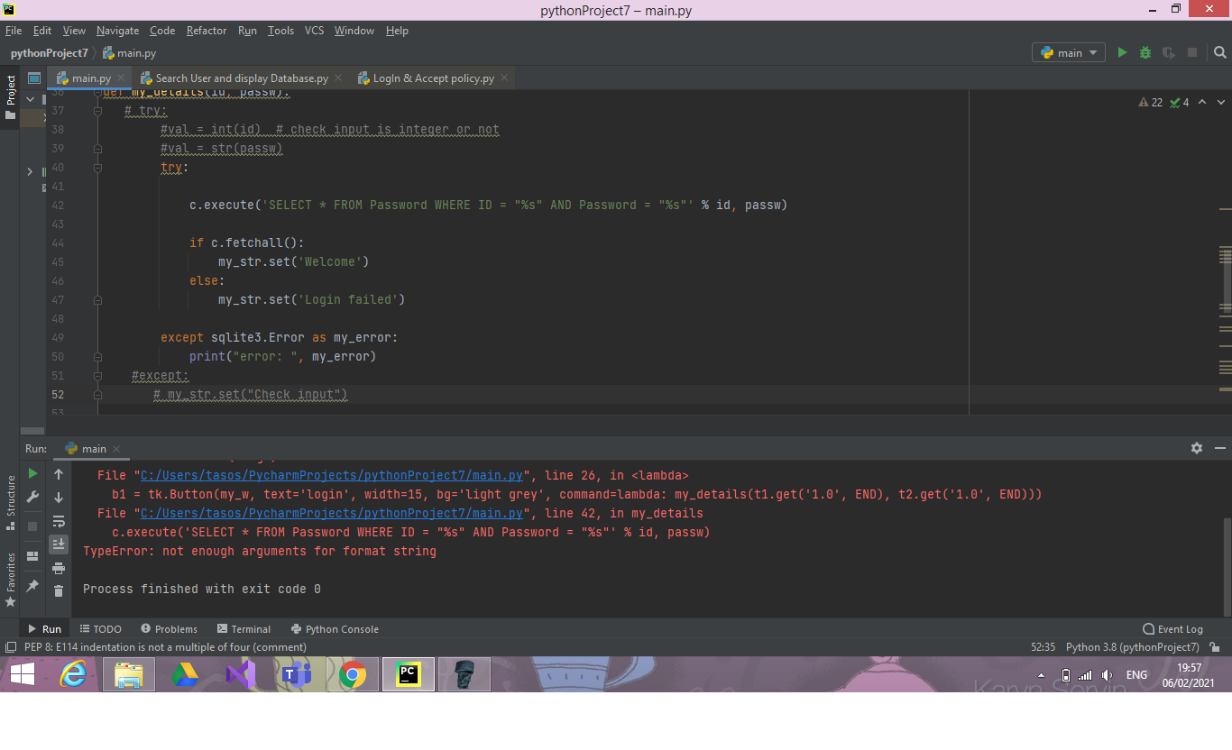

|  |  |  |  |
| --- | --- | --- | --- |
| Date: | 25/02/21 | Tested By: | Jack Davies |
| System: | Login Page | Environment: | Python |
| Objective: | No SQL injection security was implemented in our code. This caused a vulnerability which could cause a lot of damage if not corrected. | Test ID: | 6 |
| Version: | 1 | Test Type: | Boundary |
| Status: | In Process |  |  |
|  | | | |
| Type of Tests | Before | After | Result |
| * Invalid * Boundary * Valid * Wrong * Absent | The type of test that will occur will be a boundary test. No SQL injection was implemented. | The type of test in the above screenshot is a boundary test. The line that the error occurs is SELECT * FROM Password WHERE ID = ? AND Password = ? % id, passw) | This test was unsuccessful. If the user enters a legitimate search value, for example, 1478, in the above statement then all fine. But if they try something untoward, for example, 1478'; DROP TABLE Password; then the results are fatal.  The statement passes ID and Password from the client directly to the database, without performing any sort of check or validation. This sort of code is perfect for inviting SQL injection.  Test plan 7 will show how we will correct this vulnerability. |

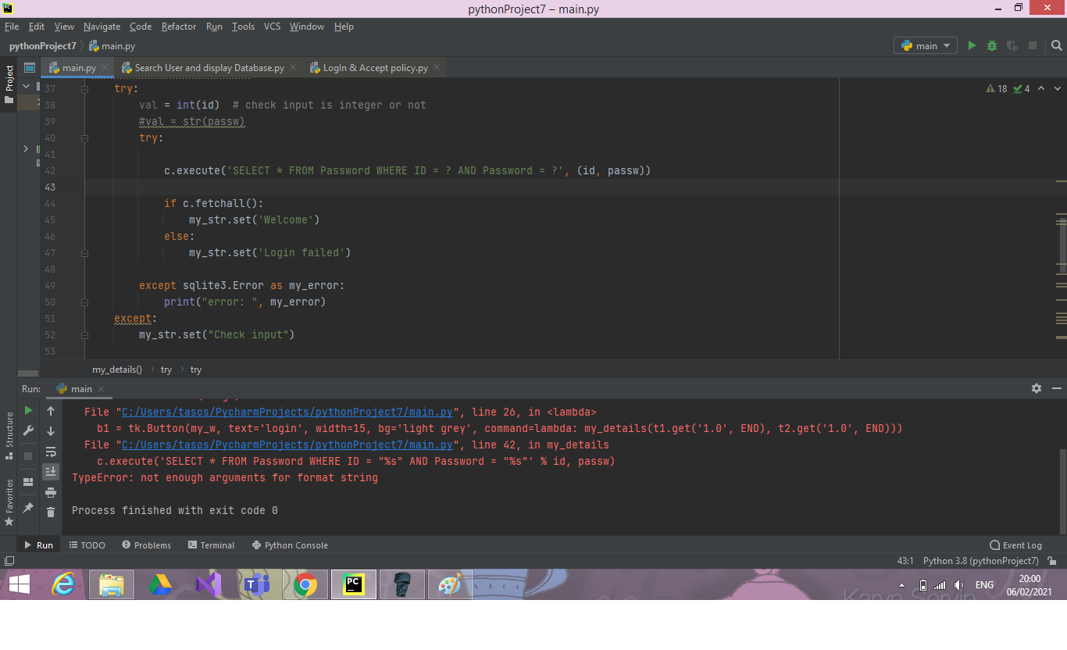Test Plan 7

|  |  |  |  |
| --- | --- | --- | --- |
| Date: | 25/02/21 | Tested By: | Jack Davies |
| System: | Login Page | Environment: | Python |
| Objective: | No SQL injection security was implemented in our code. This caused a vulnerability which could cause a lot of damage if not corrected. | Test ID: | 7 |
| Version: | 2 | Test Type: | Boundary |
| Status: | In Process |  |  |
|  | | | |
| Type of Tests | Before | After | Result |
| * Invalid * Boundary * Valid * Wrong * Absent | The type of test that will occur will be a boundary test. No SQL injection was implemented. | The type of test in the above screenshot is a boundary test. The line that the error occurs was SELECT * FROM Password WHERE ID = ? AND Password = ? % id, passw)  but now we have changed it to  SELECT * FROM Password WHERE ID = ? AND Password = ?, ( id, passw)) | This test was successful. In this statement, id and password are passed as named parameters. Now, the database will use the specified type and value of the parameters when executing the query, offering protection from Python SQL injection. |

Test Plan 8

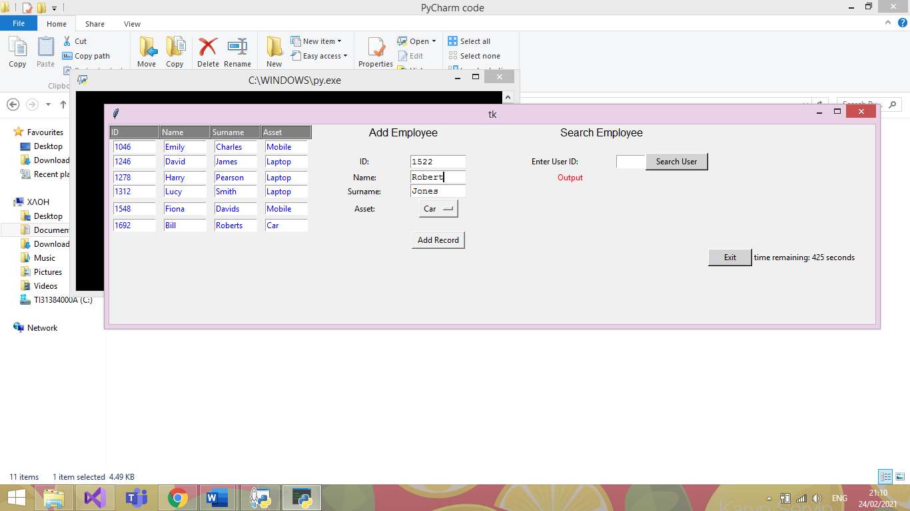

|  |  |  |  |
| --- | --- | --- | --- |
| Date: | 25/02/21 | Tested By: | Jenni Whewell |
| System: | Administrator Main Page | Environment: | Python |
| Objective: | Checking to see if details of ID, Name, Surname and Asset can be added to the database | Test ID: | 8 |
| Version: | 1 | Test Type: | Valid |
| Status: | In Process |  |  |
|  | | | |
| Type of Tests | Before | After | Result |
| * Invalid * Boundary * Valid * Wrong * Absent | The test above is to check whether user details can be added to the database with the correct values to the text boxes. | The information in the test above is to check if a user can add valid information. | From the image below, it is clearly indicated that the test was successful where the entry is seen with user ID 1522 in the table adjacent. |

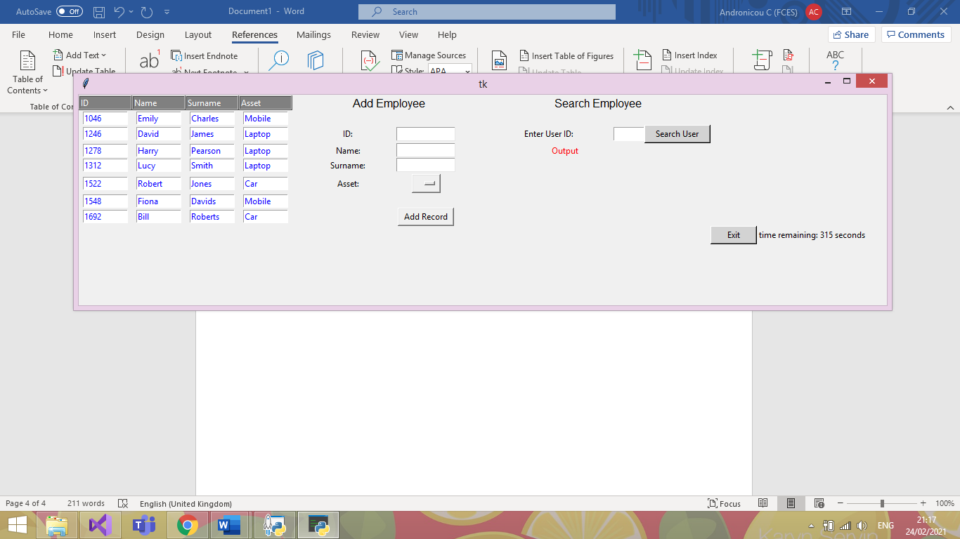

### 

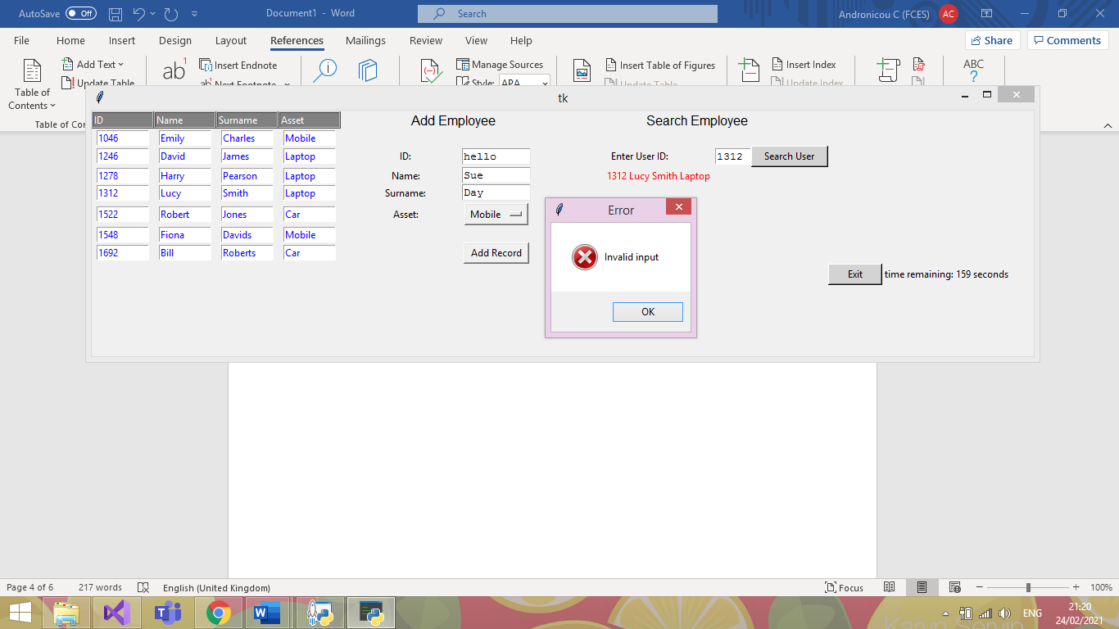Test Plan 9

|  |  |  |  |
| --- | --- | --- | --- |
| Date: | 25/02/21 | Tested By: | Jenni Whewell |
| System: | Administrator Main Page | Environment: | Python |
| Objective: | Entering a string in the user ID text box. | Test ID: | 9 |
| Version: | 1 | Test Type: | Invalid |
| Status: | In Process |  |  |
|  | | | |
| Type of Tests | Before | After | Result |
| * Invalid * Boundary * Valid * Wrong * Absent | An invalid test is executed to see if it throws an error. This type of test is known as an invalid test.  For the test we are entering the word “hello” | The type of test in the above screenshot is an invalid test. As you can see, the first name and surname have all be entered correctly with just the user ID being inputted wrong. | This test was successful because an error message has appeared informing the user that the only error that has occurred is an input error. Meaning that the user ID has been entered incorrectly. |

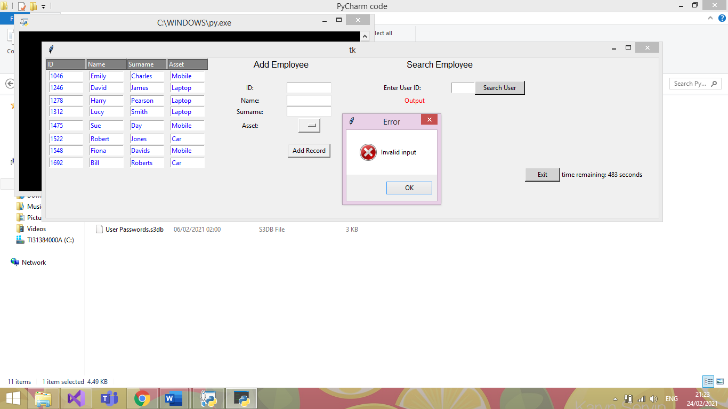Test Plan 10

|  |  |  |  |
| --- | --- | --- | --- |
| Date: | 25/02/21 | Tested By: | Jenni Whewell |
| System: | Administrator Main Page | Environment: | Python |
| Objective: | The user clicks add without entering any details. | Test ID: | 10 |
| Version: | 1 | Test Type: | Absent |
| Status: | In Process |  |  |
|  | | | |
| Type of Tests | Before | After | Result |
| * Invalid * Boundary * Valid * Wrong * Absent | An absent test is executed in the screenshot above. The purpose of the test is to check what happens if the text boxes are left empty. | An absent test is good to check so that there are no empty entries in the database. This means that the primary keys of the database will not except a NULL value. | This test was successful because an error message has appeared informing the user that the only error that has occurred is an input error. Meaning that information needs to be added to the text boxes for it to be a successful entry. |

### 

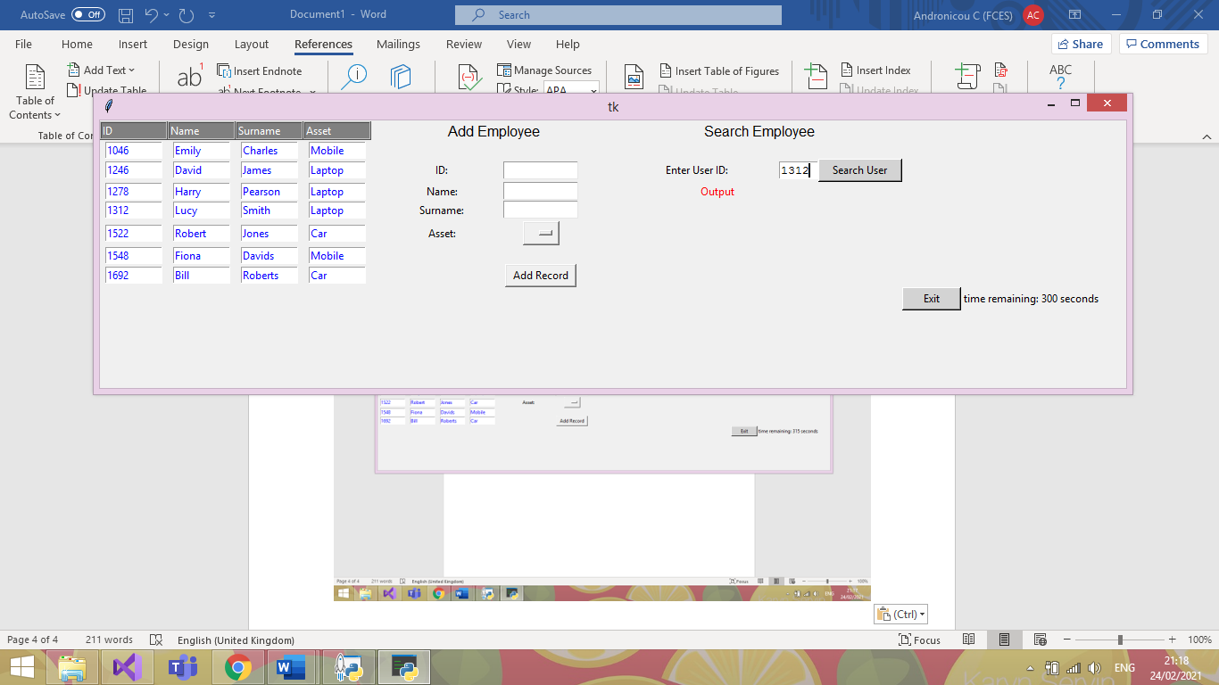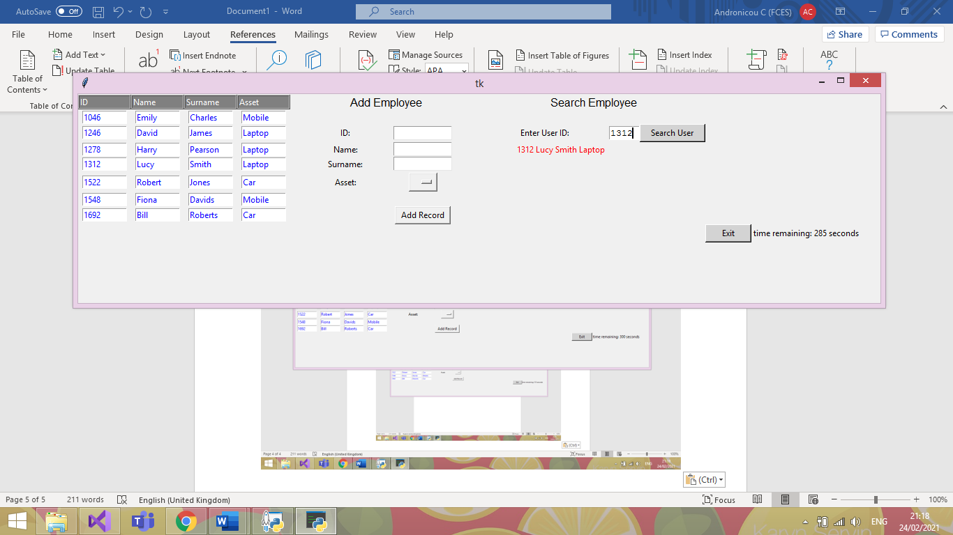Test Plan 11

|  |  |  |  |
| --- | --- | --- | --- |
| Date: | 25/02/21 | Tested By: | Jenni Whewell |
| System: | Administrator Main Page | Environment: | Python |
| Objective: | Searching for a user by their ID number. | Test ID: | 11 |
| Version: | 1 | Test Type: | Valid |
| Status: | In Process |  |  |
|  | | | |
| Type of Tests | Before | After | Result |
| * Invalid * Boundary * Valid * Wrong * Absent | In the first screenshot, the user ID 1312 is entered for the purpose of the search test. The purpose of a valid test is to check if the program is outputting the correct result when asking the system for details. | The details that should be outputted in the result of the test should include the first name, surname, and the asset that the employee has taken.  With the user ID 1312, the name should be Lucy smith and the asset should be a laptop. | This test was successful because all the correct details have appeared. This means that the form can take valid inputs from the system and it will output the correct details. |

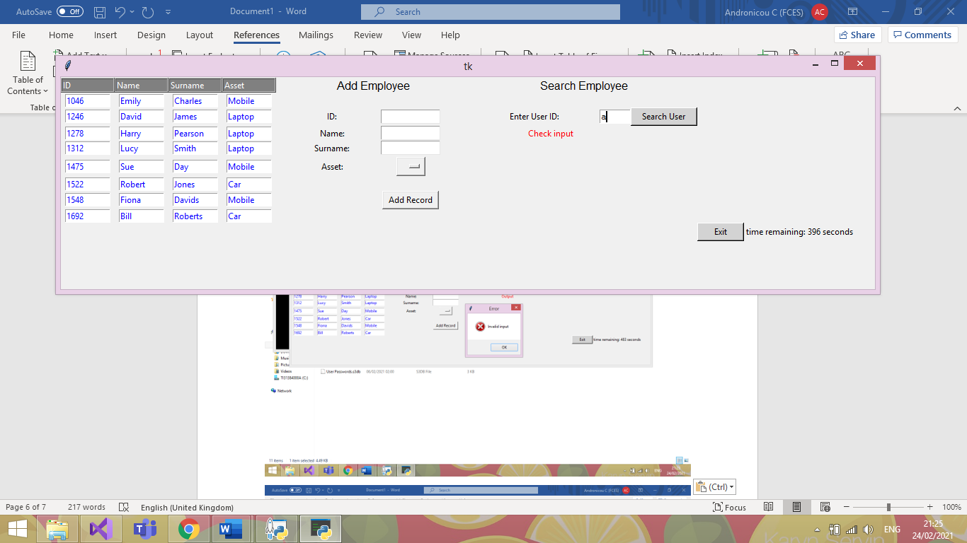Test Plan 12

|  |  |  |  |
| --- | --- | --- | --- |
| Date: | 25/02/21 | Tested By: | Jenni Whewell |
| System: | Login Page | Environment: | Python |
| Objective: | The user enters invalid input to search | Test ID: | 12 |
| Version: | 1 | Test Type: | Invalid |
| Status: | In Process |  |  |
|  | | | |
| Type of Tests | Before | After | Result |
| * Invalid * Boundary * Valid * Wrong * Absent | The type of test that will occur will be an Invalid test. This test will try to search for a user by a string which is not the correct data type. | An invalid test is good to check so that there are no unwanted entries in the database. This means that the test will not return the first entry in the database if the input is wrong. | This test was successful because an error message can be seen in red to indicate to check the input. |

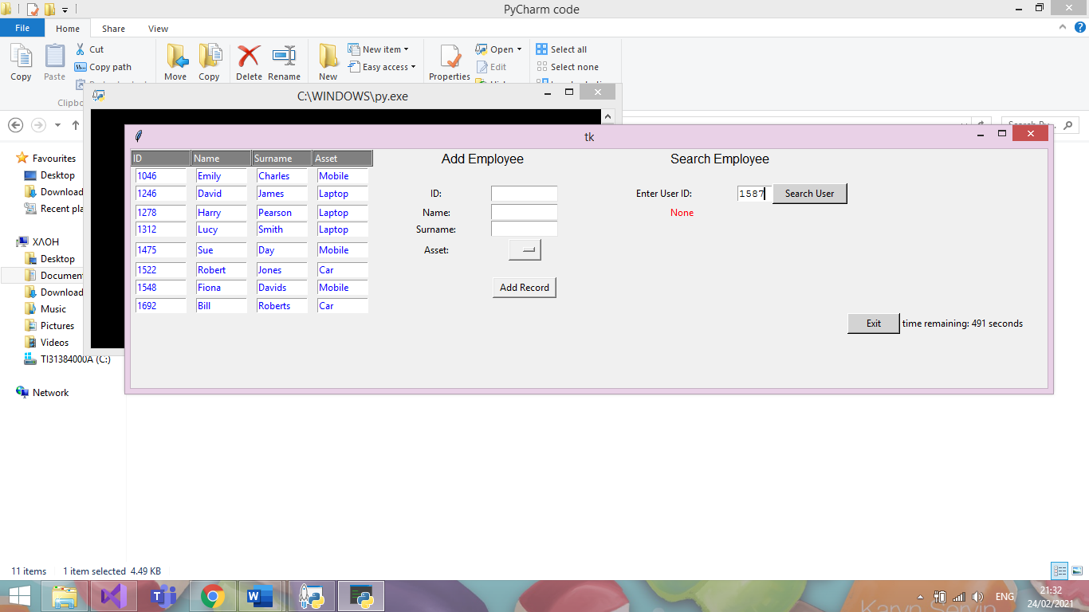Test Plan 13

|  |  |  |  |
| --- | --- | --- | --- |
| Date: | 25/02/21 | Tested By: | Jenni Whewell |
| System: | Administrator Main Page | Environment: | Python |
| Objective: | Entering a user’s ID that is not present. | Test ID: | 13 |
| Version: | 1 | Test Type: | Wrong |
| Status: | In Process |  |  |
|  | | | |
| Type of Tests | Before | After | Result |
| * Invalid * Boundary * Valid * Wrong * Absent | The type of test that will occur will be a wrong test. This test will try to search for a user using the correct data type, however, the user does not exist. | A wrong test is good to check so that a user is not getting accused of taking out an asset if that is not the case. This is vital to ensure that correct data is being stored in the database. | This test was successful because an error message can be seen in red to indicate that no such user exists in the database. Which in this case is true. |

### 

Test Plan 14

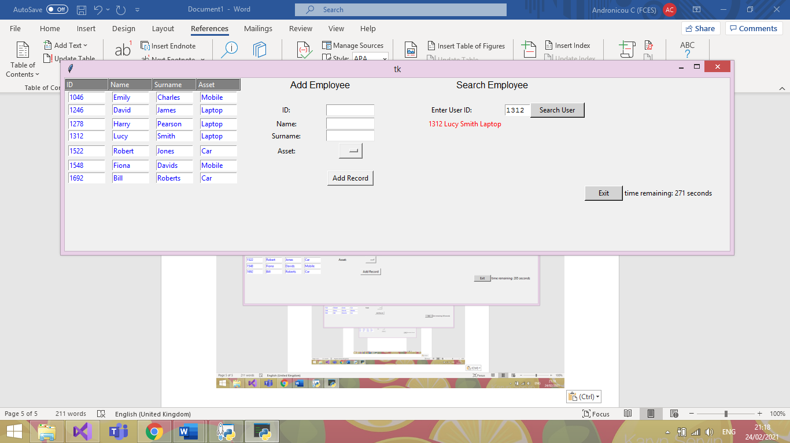



|  |  |  |  |
| --- | --- | --- | --- |
| Date: | 25/02/21 | Tested By: | Jenni Whewell |
| System: | Login Page | Environment: | Python |
| Objective: | Checking that the exit buttons timer works for security purposes. | Test ID: | 14 |
| Version: | 1 | Test Type: | Valid |
| Status: | In Process |  |  |
|  | | | |
| Type of Tests | Before | After | Result |
| * Invalid * Boundary * Valid * Wrong * Absent | This valid test is to check whether the timer for the exit button works successful, counting down so that the form closes within the time limit unless something is inputted to the GUI. | In the first screenshot, the timer is seen starting when the form is initially opened.  This test is important as this means that if the user does not interact with the GUI then it will shut down.  This allows for the system to be secure so if the user leaves to computer unattended then unauthorised users cannot access it. | As you can seen from the second screenshot, the test was successful with the time remaining decreasing from the first screenshot. An important aspect of authorisation and authentication. |

### 

Test Plan 15

|  |  |  |
| --- | --- | --- |
| Before Deleting | When Deleting | After Deleting |
|  |  |  |

|  |  |  |  |
| --- | --- | --- | --- |
| Date: | 25/02/21 | Tested By: | Jenni Whewell |
| System: | Administrator Main Page | Environment: | Python |
| Objective: | Checking that the delete function works as expected | Test ID: | 15 |
| Version: | 1 | Test Type: | Valid |
| Status: | In Process |  |  |
|  | | | |
| Type of Tests | Before | After | Result |
| * Invalid * Boundary * Valid * Wrong * Absent | This test is important as it utilizes the ability to delete a user if they no longer have an asset in the company or end up leaving the company. | The first screenshot indicates all the entries in the database. The second screenshot is what happens when a user is selected. For the purpose of the, test user ID 1278. The outcome should see this user being deleted from the database and the entries below and above should all stay the same. | The test was partially successful with the entry that was required to be deleted was. However, one thing that does happen is that it duplicates another value in the database.  For fixing this error, we could set the primary key which is the user ID to not except duplicate values and this will stop the error. This can be fixed in the next phase. |

Test Plan 16

|  |
| --- |
| Before Asset Update |
|  |
| After Asset Update |
|  |

|  |  |  |  |
| --- | --- | --- | --- |
| Date: | 25/02/21 | Tested By: | Jenni Whewell |
| System: | Administrator Main Page | Environment: | Python |
| Objective: | Checking that the update function works as expected | Test ID: | 15 |
| Version: | 1 | Test Type: | Valid |
| Status: | In Process |  |  |
|  | | | |
| Type of Tests | Before | After | Result |
| * Invalid * Boundary * Valid * Wrong * Absent | This test is important as it utilizes the ability to update a user’s asset if needed. | For the purpose of the test, user ID 1278 is used. The outcome should see the specified user asset is changed to the asset selected by the user. | The test was successful with the entry that was required to be updated was. |

### Unit Testing

The main goal with the automatic testing is to ensure that any quick refactoring’s done to the project, will not damage the core functionality. Due to our project not only using a GUI, but also its use of SQLite to add a database, it makes it very difficult to conduct traditional Unit testing appropriately.

Additionally, I have attempted to incorporate DocTesting in hopes to have more success with the GUI/Database but still to no avail.

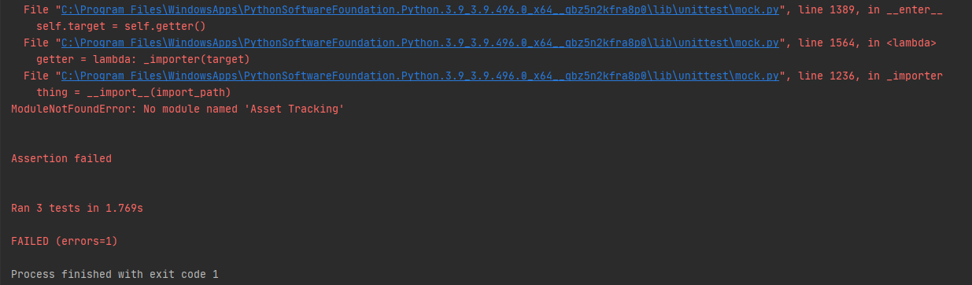

Due to the 2 external dependencies, as aforementioned, it increases the difficulty of employing these forms of testing quite significantly as you can see in the above *PrintScreen*. This as far as my research has shown, there is no real way for the testing suite to ‘see’ the changes made to the GUI.

We can however test that our input validation works correctly, and that the program wont crash when given values it cannot handle. Essentially it is only the core logic that may be tested through these means, other areas of our program must be tested manually to validate their current working state.

### Database GUI

**Functions being tested:**

* Add_Data()
* Search(ID)

**Test Purpose:**

* Check correct exceptions thrown where appropriate.
* 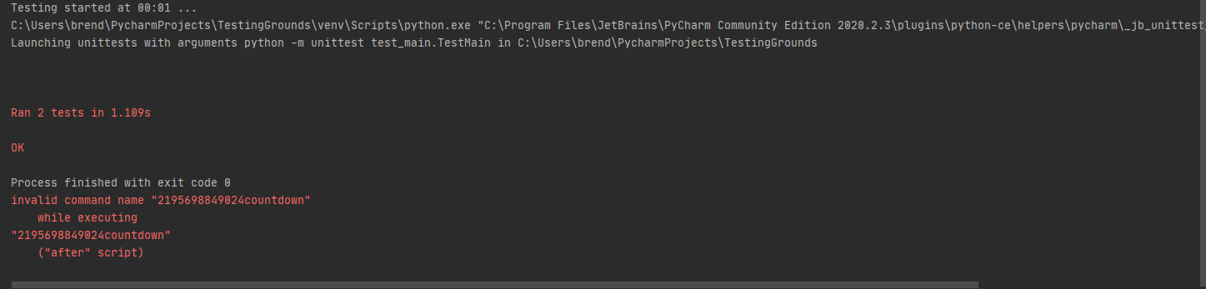Logic works as expected.

### Log In Form (with DB verification)

**Functions being tested:**

* My_details()

**Test Purpose:**

* Check correct exceptions thrown where appropriate.

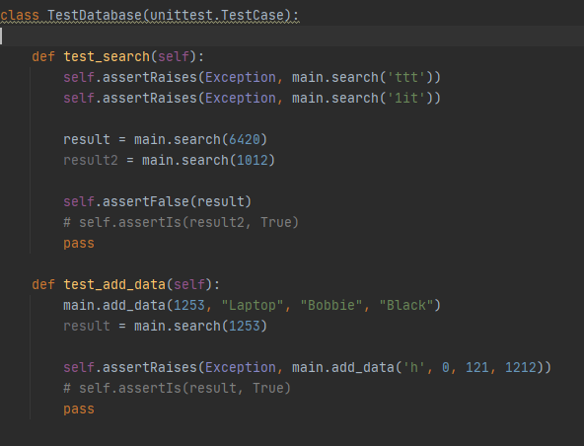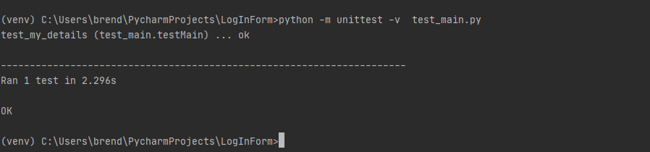

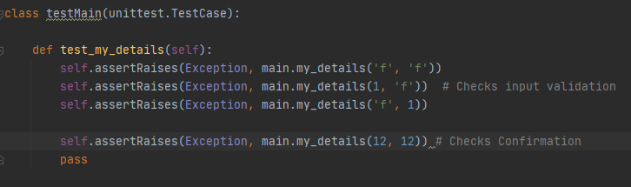References/Helpful Links (Why GUI test automation bad)

[https://www.theregister.com/2007/10/22/gui_unit_testing/#:~:text=Of%20course%20GUI%20applications%20can,test%20GUIs%22%20because%20it's%20difficult.](https://www.theregister.com/2007/10/22/gui_unit_testing/%23:~:text=Of%20course%20GUI%20applications%20can,test%20GUIs%22%20because%20it's%20difficult.)

Arguments that GUIs should be tested with Units in mind, however not the UI itself necessarily but rather the implemented logic of the program. Essentially confirms the methods we have followed, i.e., test base logic, throwing exceptions so on, rather than the GUIs response to them.

<https://softwareengineering.stackexchange.com/questions/207274/should-i-bother-to-write-unit-test-for-ui-ux-components>

A forum exclaiming the same thing, Unit testing has its place more for actual logic testing whereas testing the GUI and how it reacts to the code is more for **‘functional/integration’** testing.

<https://agilewarrior.wordpress.com/2015/04/18/classical-vs-mockist-testing/>

This is where I found the information regarding the ‘Mock’ class and how it can be used for emulating objects in code that you don’t necessarily want to run, a good way to explain it is if you were say hooking up to a website, rather than actually connecting to the site during every test case you run, it’ll instead connect to a ‘mock’ version of the website thus emulating the experience of connecting to a site.

Useful when working with something difficult to test or is legacy code/cannot be refactored.

I did try to implement this also, I tried to emulate a GUI framework to work with but had no real research to help with that one. I then tried to emulate the DB just to test the add_Data() functionality, but I then had issues with SQL queries trying to run on the ‘fake’ DB.

A way we could implement the unit testing appropriately is by using an MVC pattern (cool how our modules cross over though!). Due to it being split into, you could say, ‘units’ it makes it far simpler to test. Again, only the core functionality of a given function can be tested, GUI testing still proves to be best done by human eye (as far as my research shows so far anyway, it can be done in other frameworks quite easily but so far nothing for tkinter within reason)

<https://www.semicolonworld.com/question/59599/how-do-i-run-unittest-on-a-tkinter-app>

So, this link is the closest to a solution I have found, and it entails essentially setting the GUI to execute in another thread while the testing continues in the main thread. Of course, my knowledge of threading is stretched as it is, but in this sense, I was completely lost on what to do. However, it does seem like a viable option for the future.

### Attempts:

This was an attempt to create a fake database just to test the add_data function but with a separate database not to edit our original. This did not work, at all.

class TestDatabase(unittest.TestCase):  
  
 def setUp(self):  
 *"""  
 Setup a temporary database  
 """* conn = sqlite3.connect("testDatabase.db")  
 cursor = conn.cursor()  
 # create a table  
 cursor.execute("""CREATE TABLE test  
 (id text, name text, surname text,  
 options text)  
 """)  
 # insert some data  
 cursor.execute("INSERT INTO test VALUES "  
 "('1012', 'Dave', 'Parkhouse',"  
 "'Laptop'")  
 # save data to database  
 conn.commit()  
 # insert multiple records using the more secure "?" method  
 testVals = [('1654', 'Andy', 'Hunter',  
 'Laptop'),  
 ('9865', 'Red', 'Davies',  
 'Laptop'),  
 ('6545', 'Krutch',  
 'Jones', 'Tablet'),  
 ('7845', 'Lee', 'Evans',  
 'Laptop')]  
 cursor.executemany("INSERT INTO test VALUES (?,?,?,?)",  
 testVals)  
 conn.commit()  
 def tearDown(self):  
os.remove("mydatabase.db")

This was then an attempt at using ‘mock’ to emulate a database, again this did not work, at all. The SQL queries were not able to execute on my ‘test’ DB sadly so would just get constant exceptions.

# Final GUI Design

Log In page

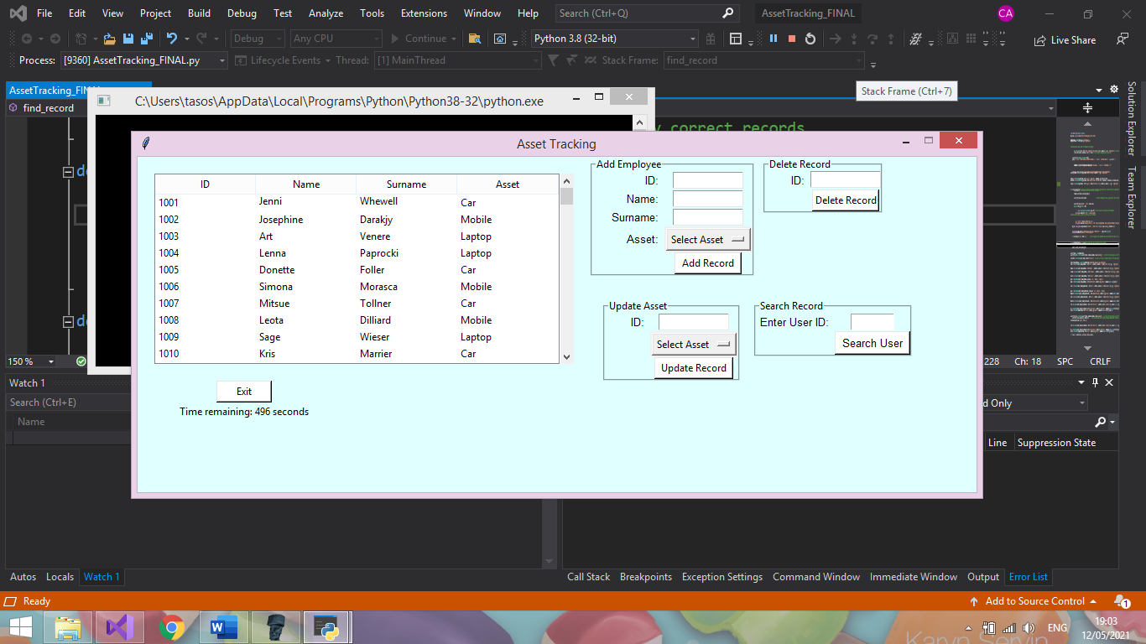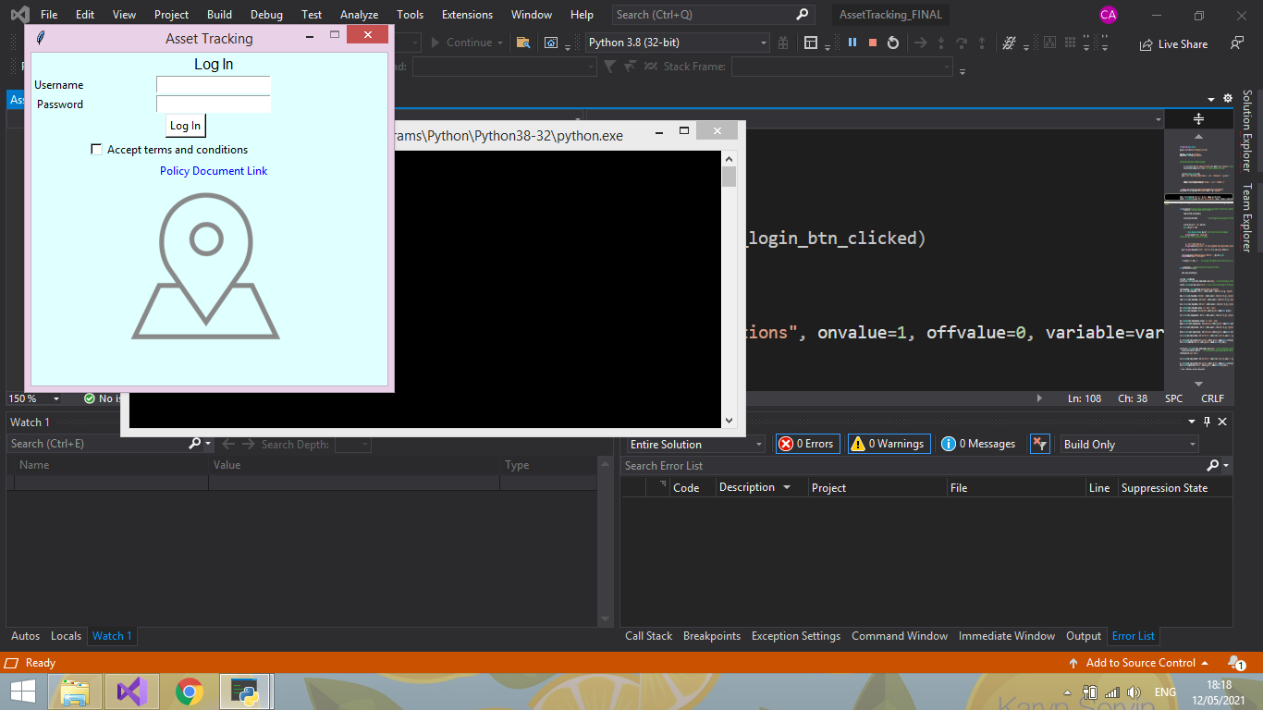

Administrator Main page

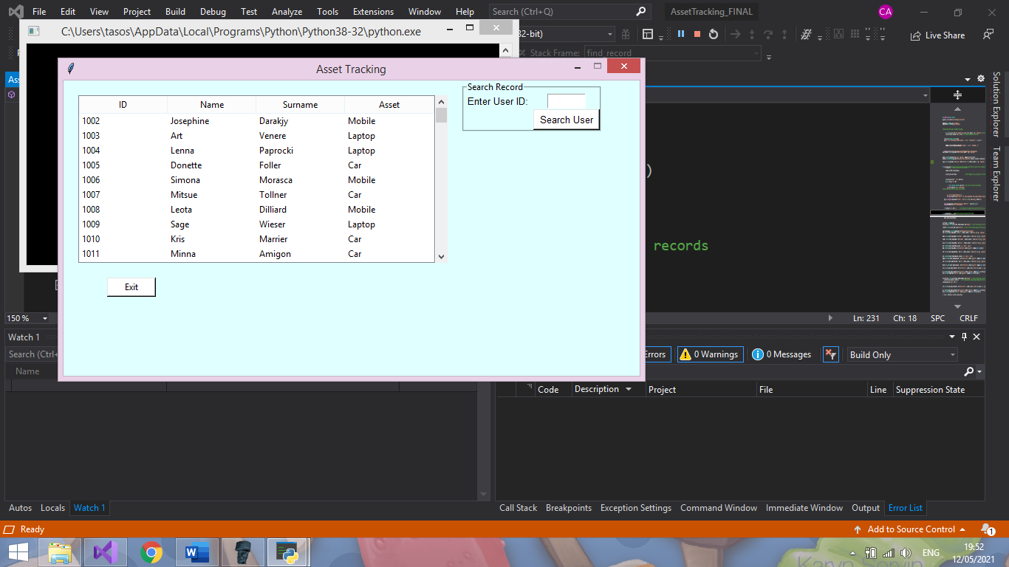

Employee Main page

## Gantt Chart

### Phase 1

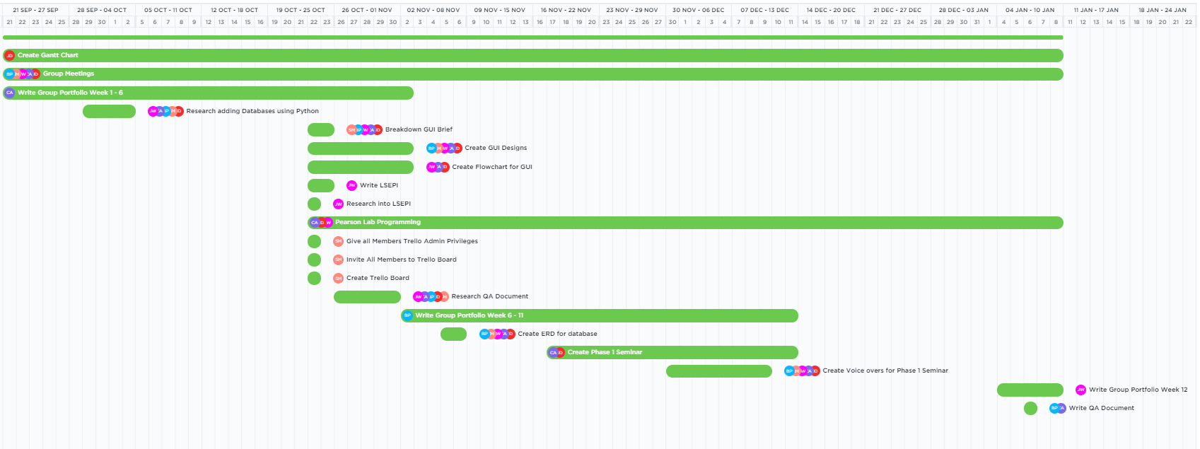

### Phase 2

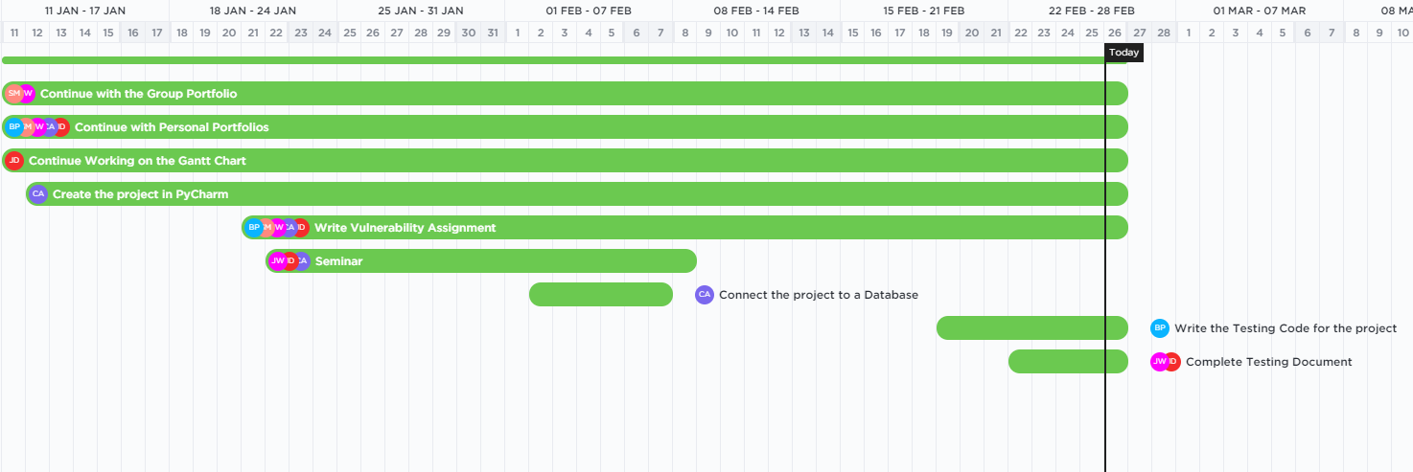

### Graphical user interface, text, application, email Description automatically generatedPhase 3

### Useful Links

Our ‘ClickUp’ account:

<https://app.clickup.com/4514370/v/l/49rj2-50>

Phase 1 Chart:

<https://app.clickup.com/4514370/v/g/49rj2-57>

Phase 2 Chart:

<https://app.clickup.com/4514370/v/g/49rj2-99>